1. **USER LOING PAGE**

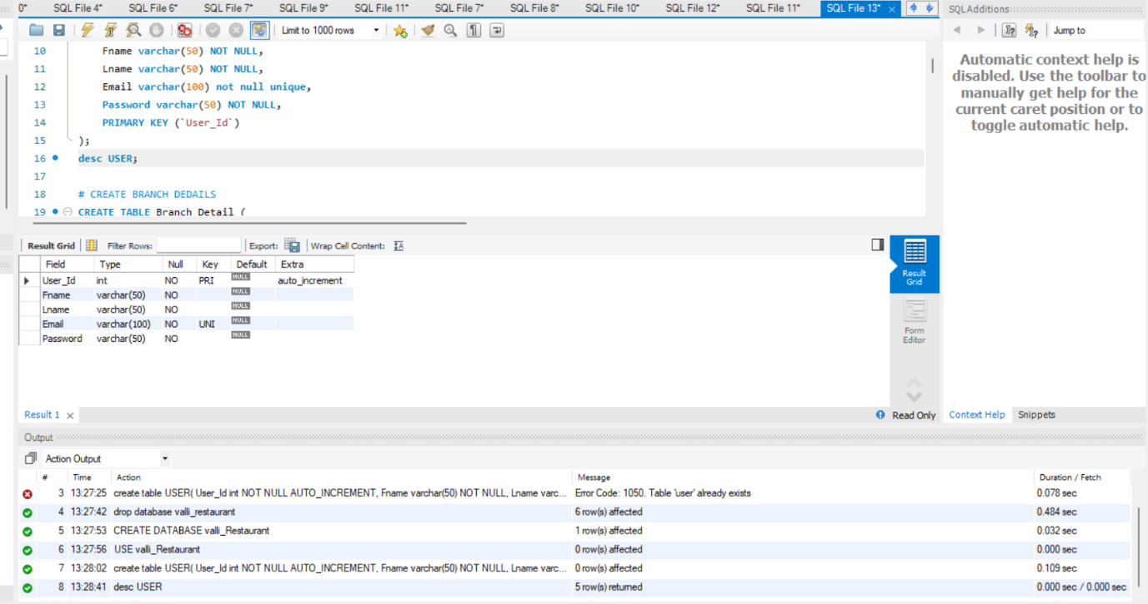

1. **CREATE BRANCH DEDAILS**

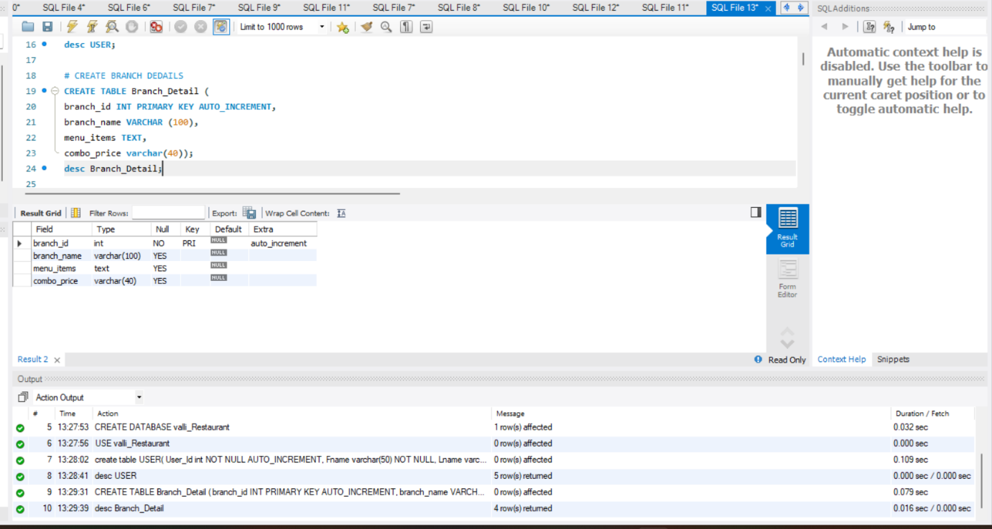

1. **VEG MENU**

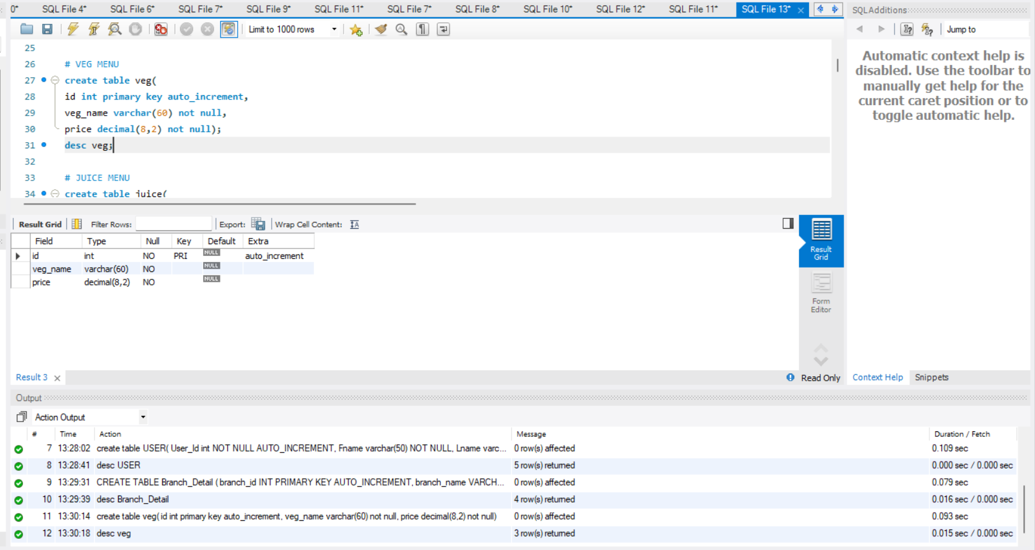

1. **JUICE MENU**

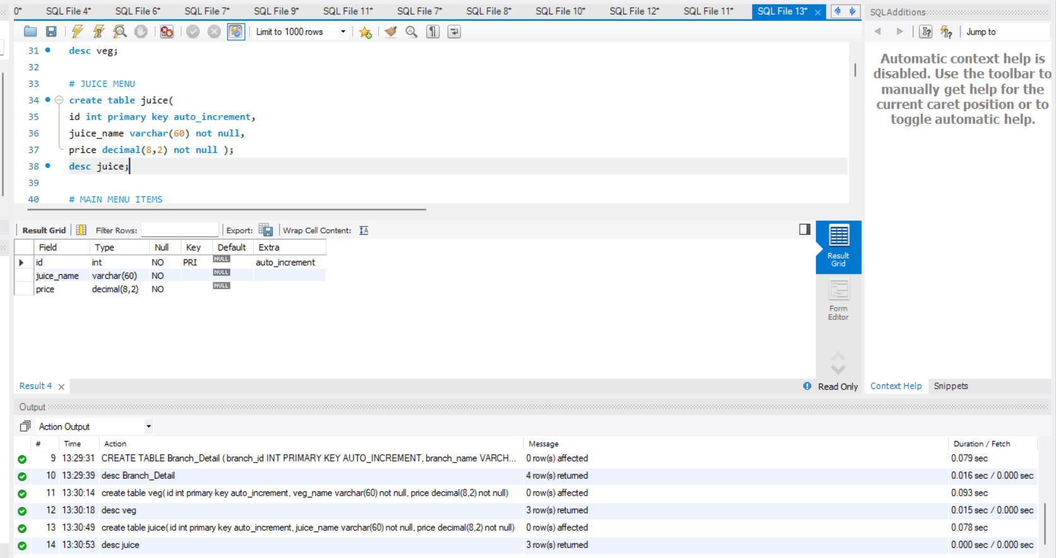

1. **MAIN MENU ITEMS**

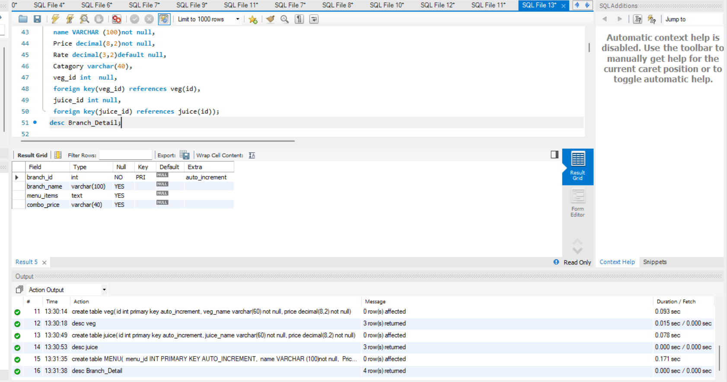

1. **CREATE CUSTOMER DEDAILS**

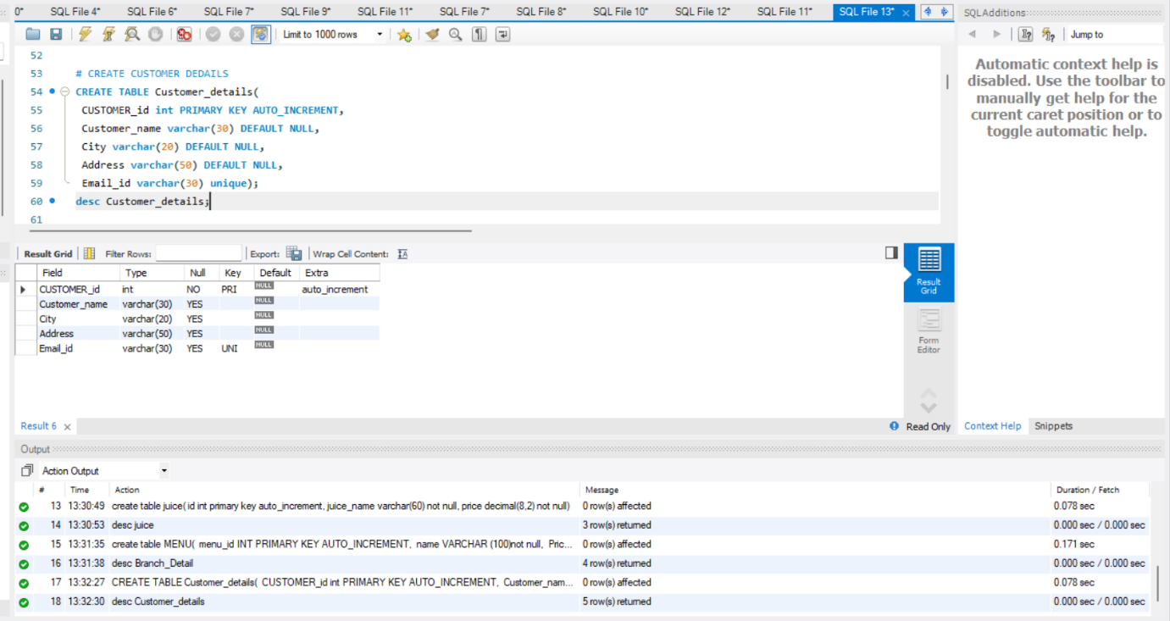

1. **SHOW TABLES**

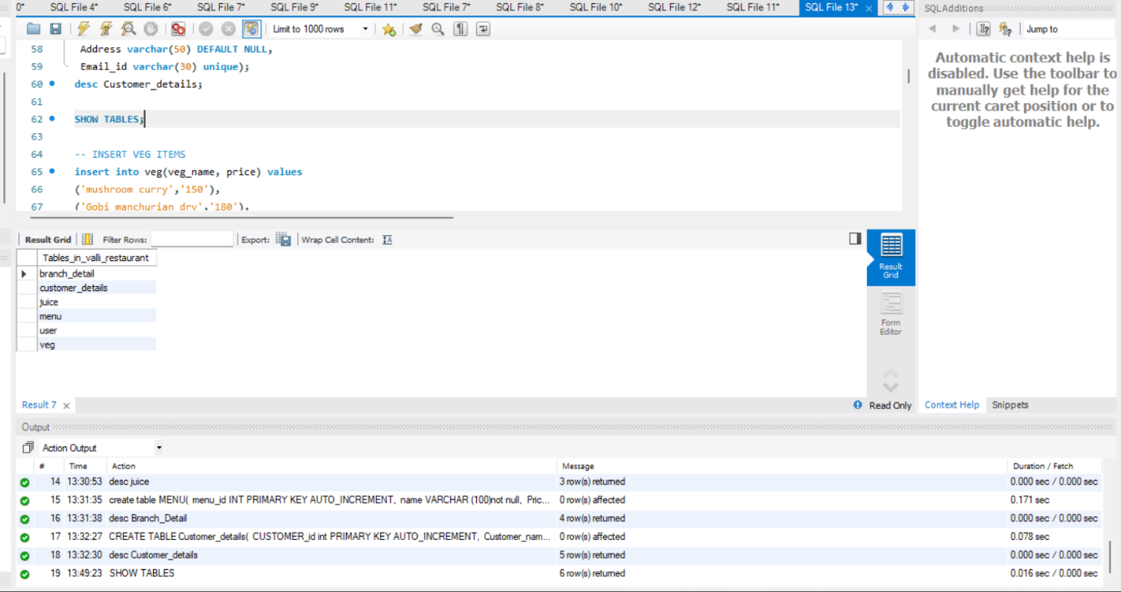

**INSERT VALUE**

1. **INSERT VEG ITEMS**

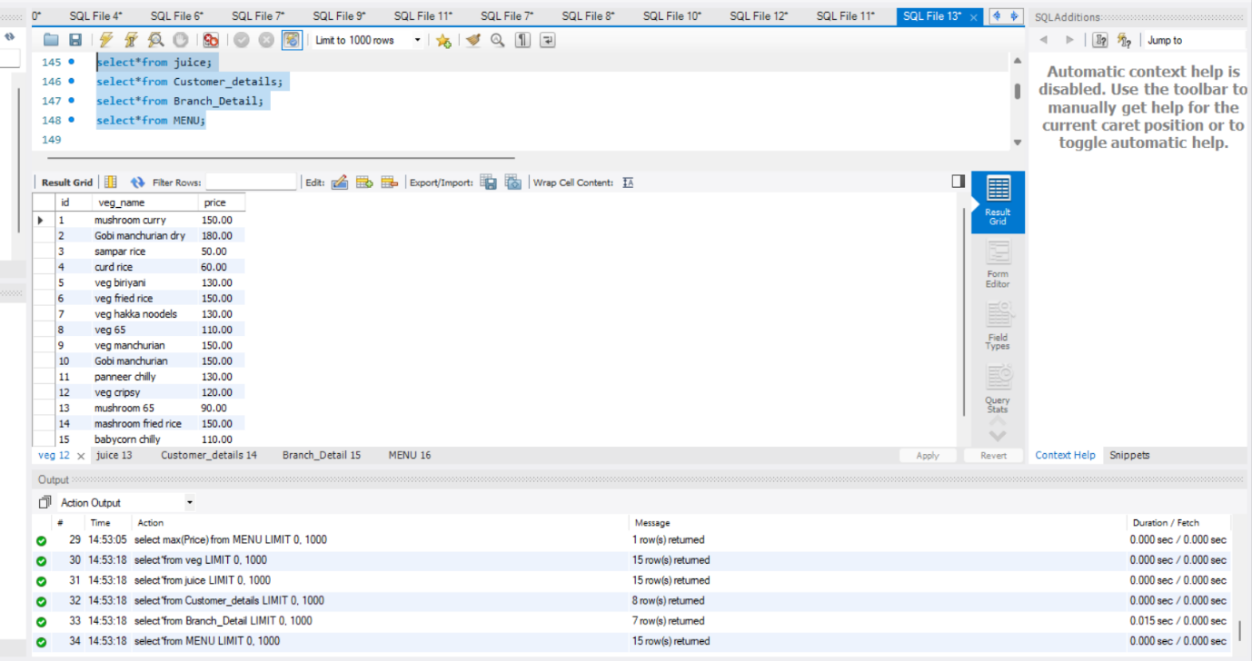

1. **INSERT JUICE ITEMS**

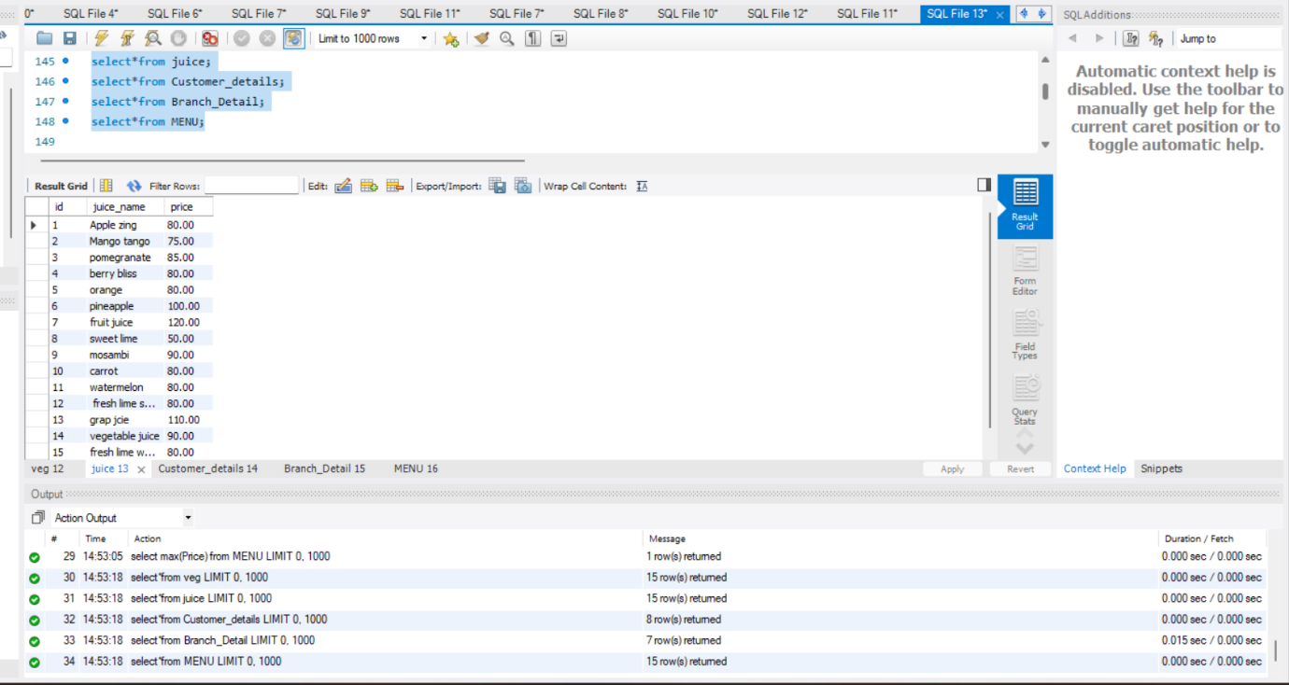

1. **INSERT CUSTOMER DEDAILSE**

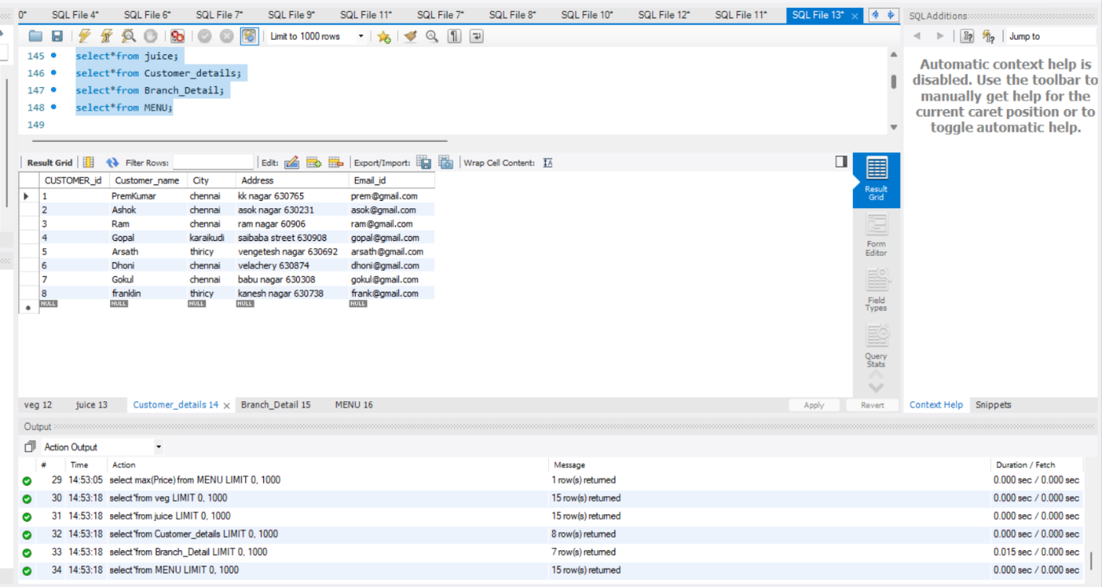

1. **INSERT BRANCH DEDAILS**

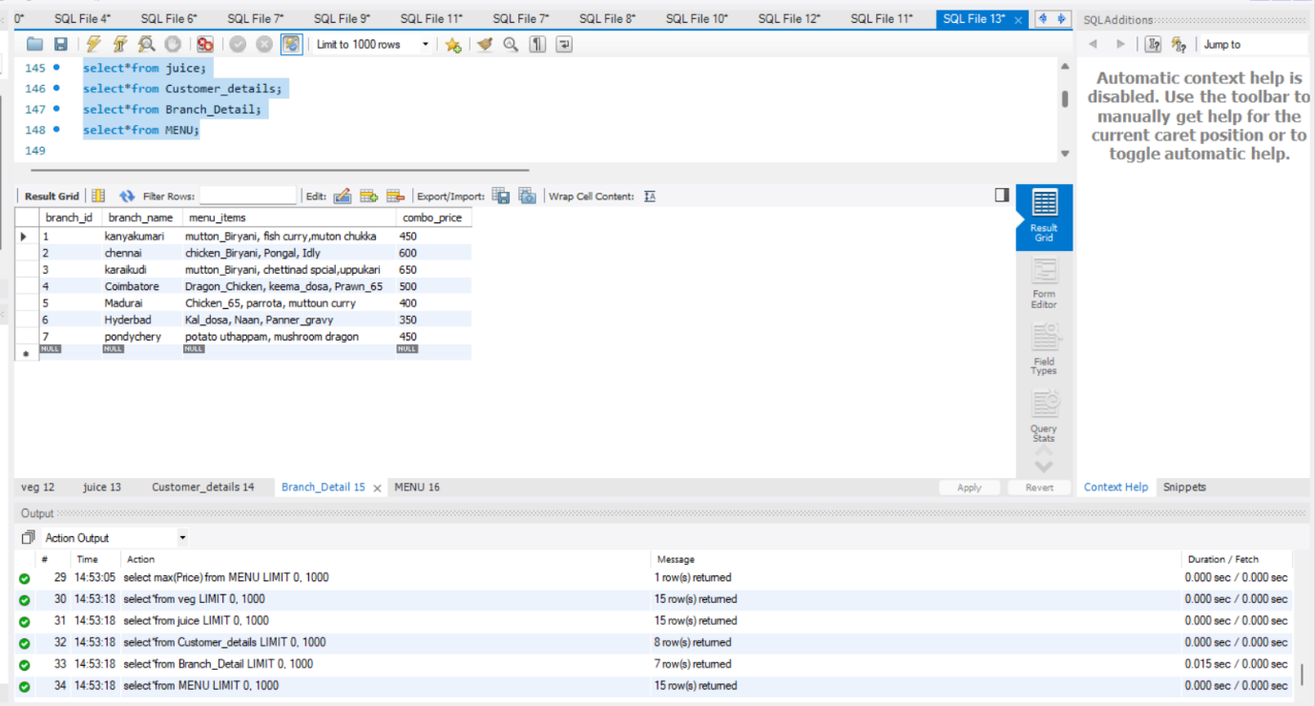

1. **INSERT MENU ITEMS**

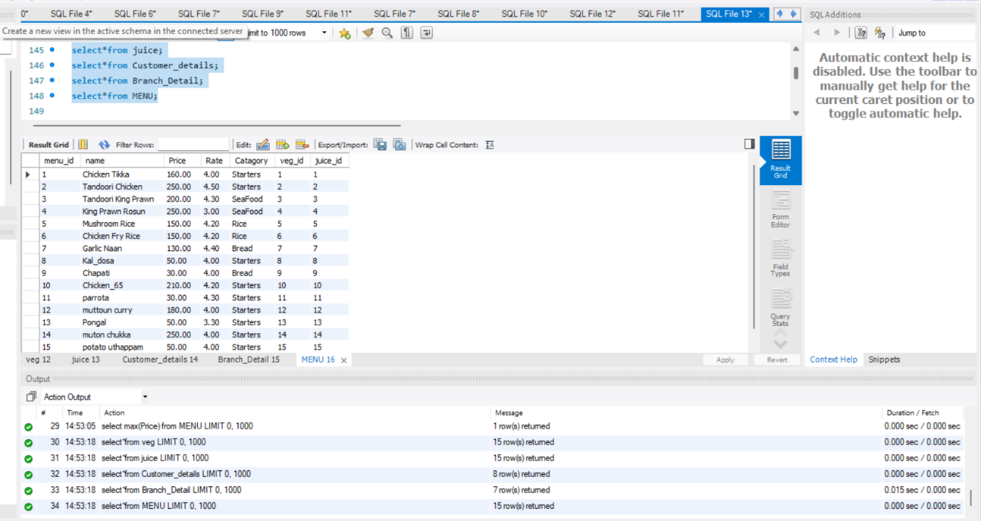

1. **JOINS**

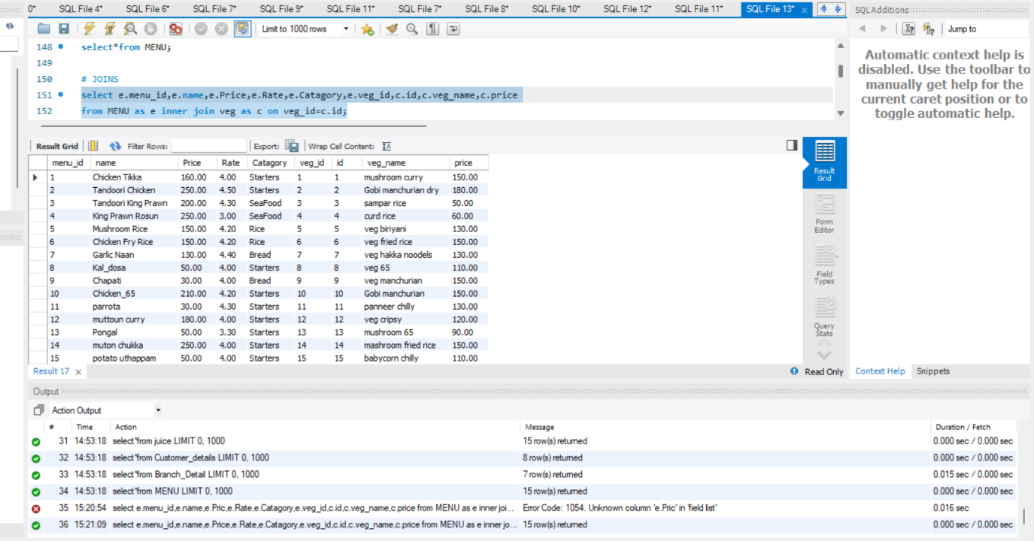

1. **INNER JOINS**

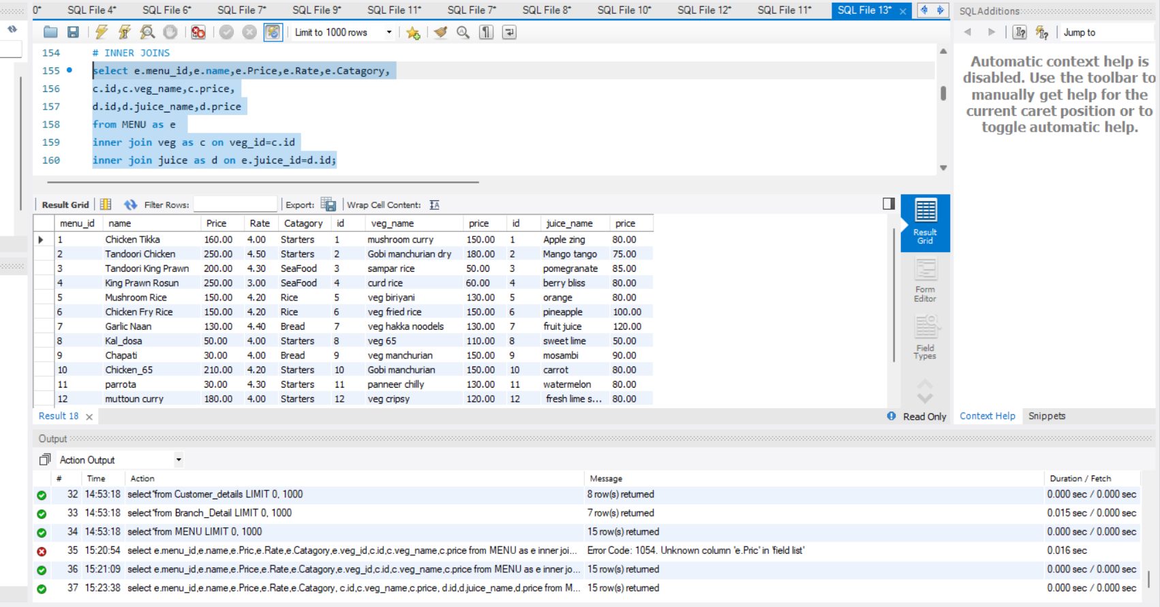

1. **CREATE RESTAURANT OWENER**

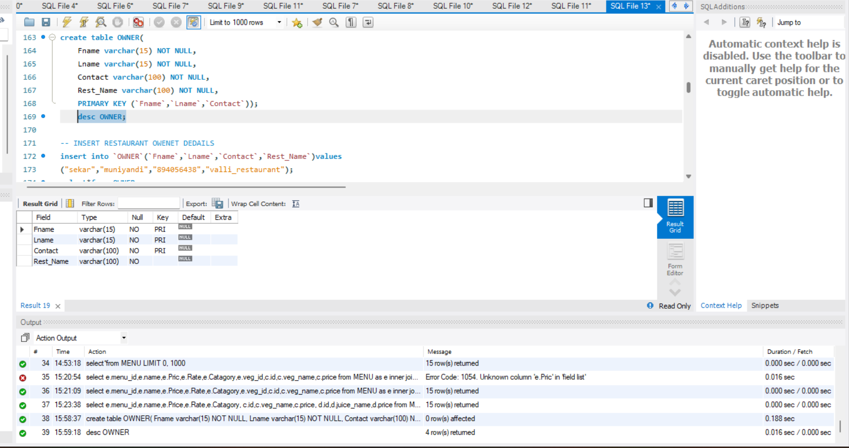

1. **INSERT RESTAURANT OWENET DEDAILS**

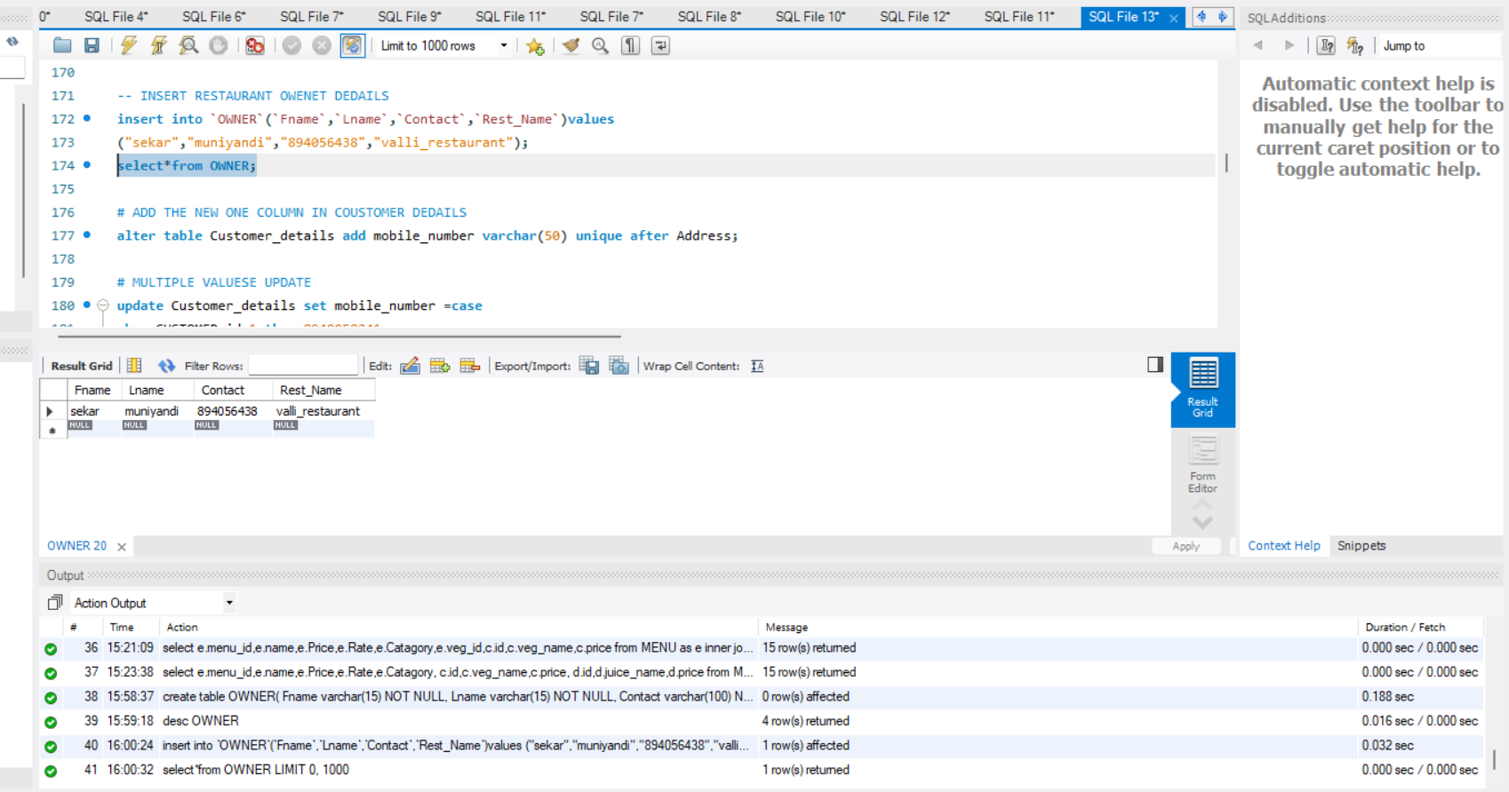

1. **ADD THE NEW ONE COLUMN IN COUSTOMER DEDAILS**

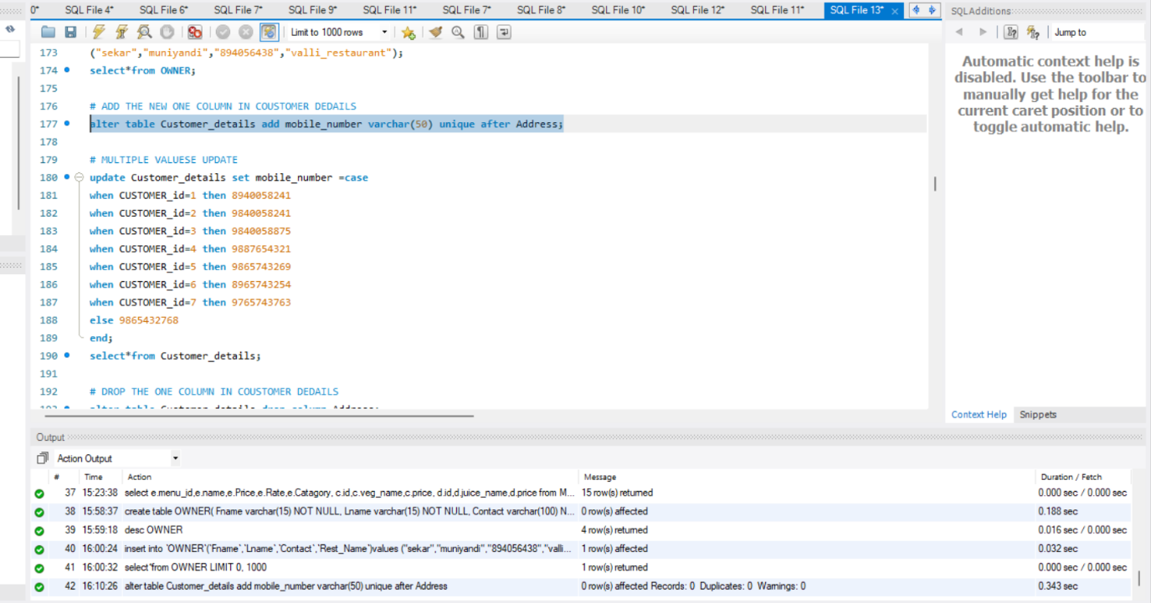

1. **MULTIPLE VALUESE UPDATE**

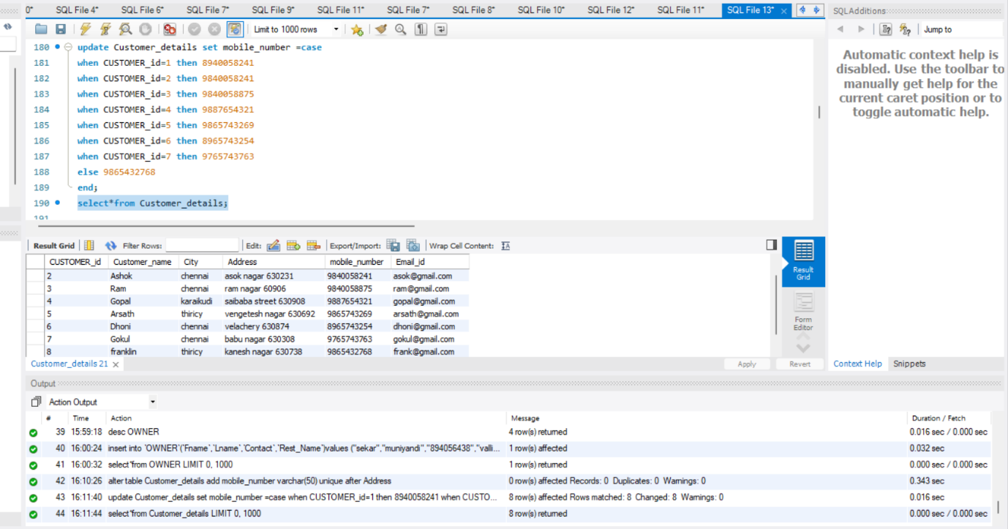

1. **DROP THE ONE COLUMN IN COUSTOMER DEDAILS**

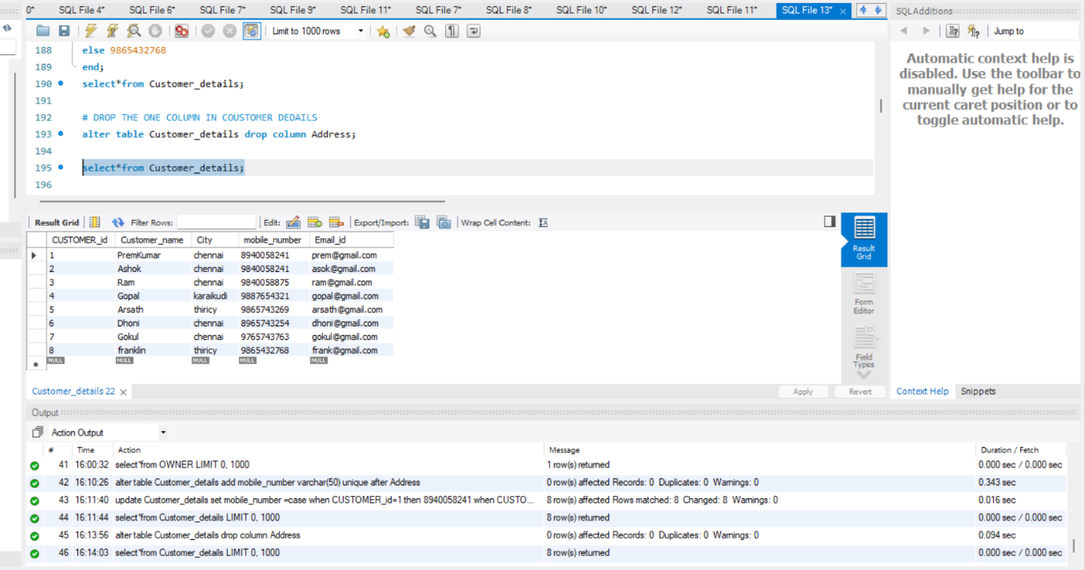

1. **AGGREGATE FUNCTION**

* **Minimum**

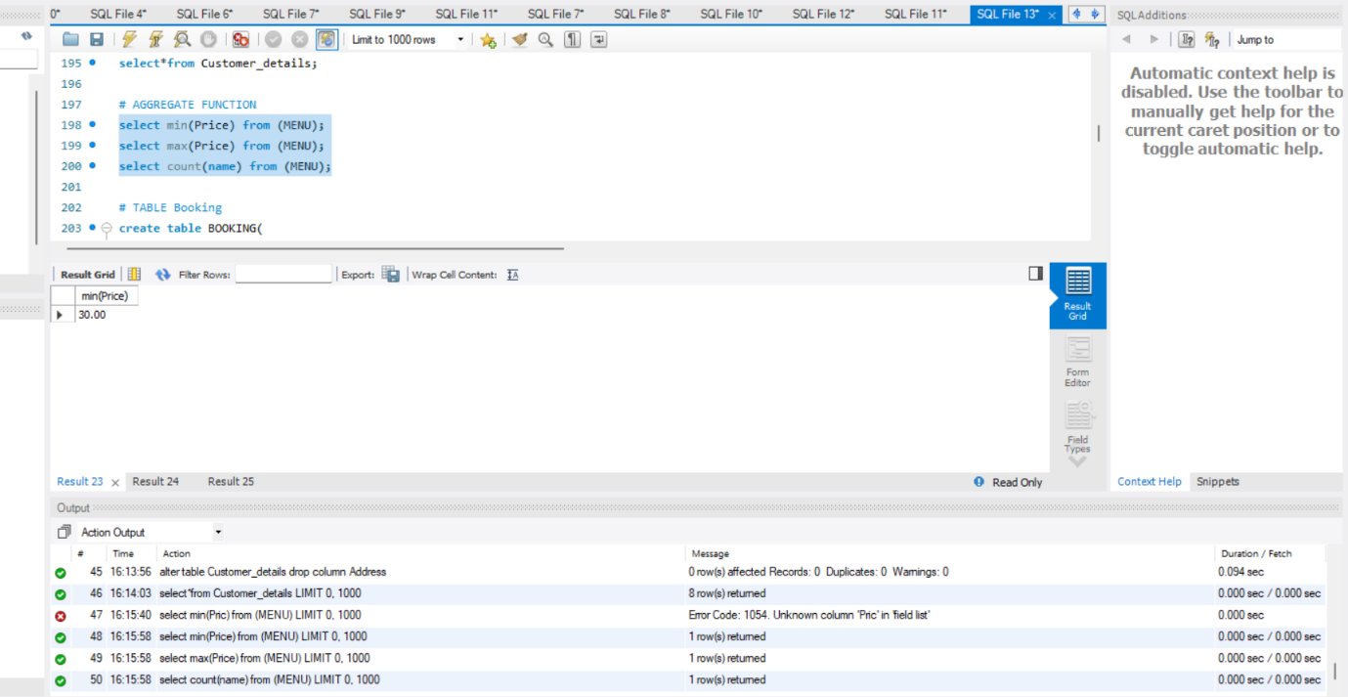

1. **AGGREGATE FUNCTION**

* **Maximum**

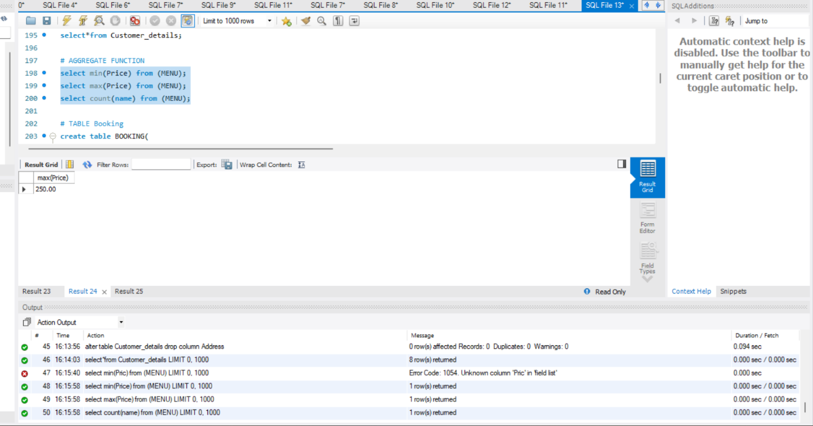

1. **AGGREGATE FUNCTION**

* **Count**

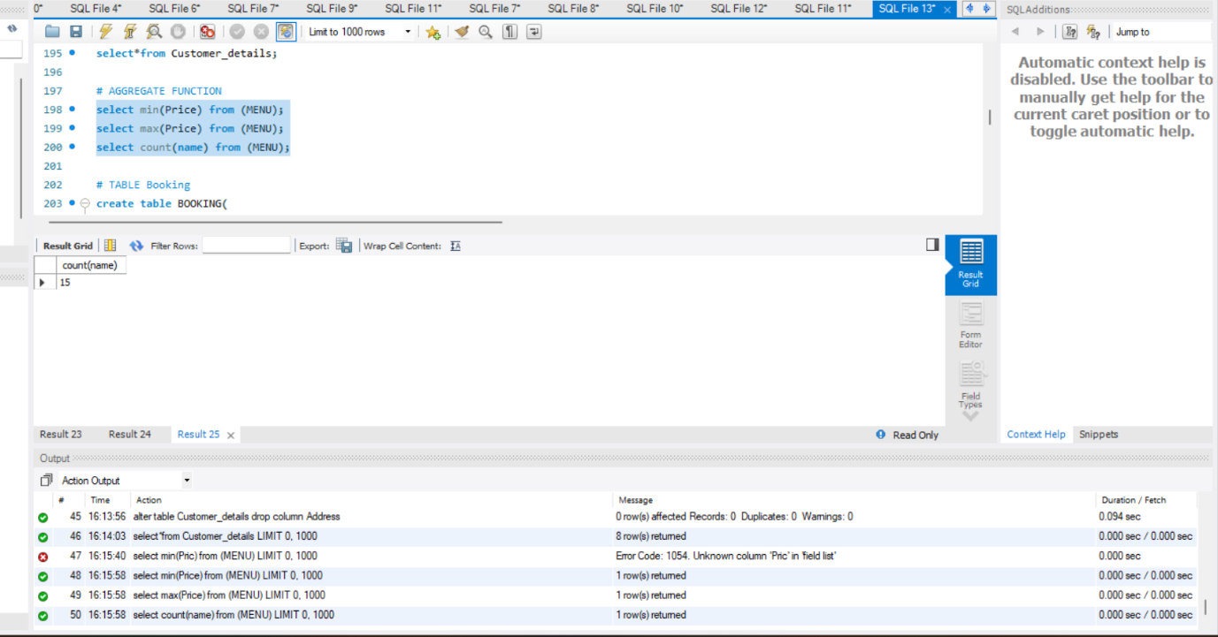

1. **TABLE Booking**

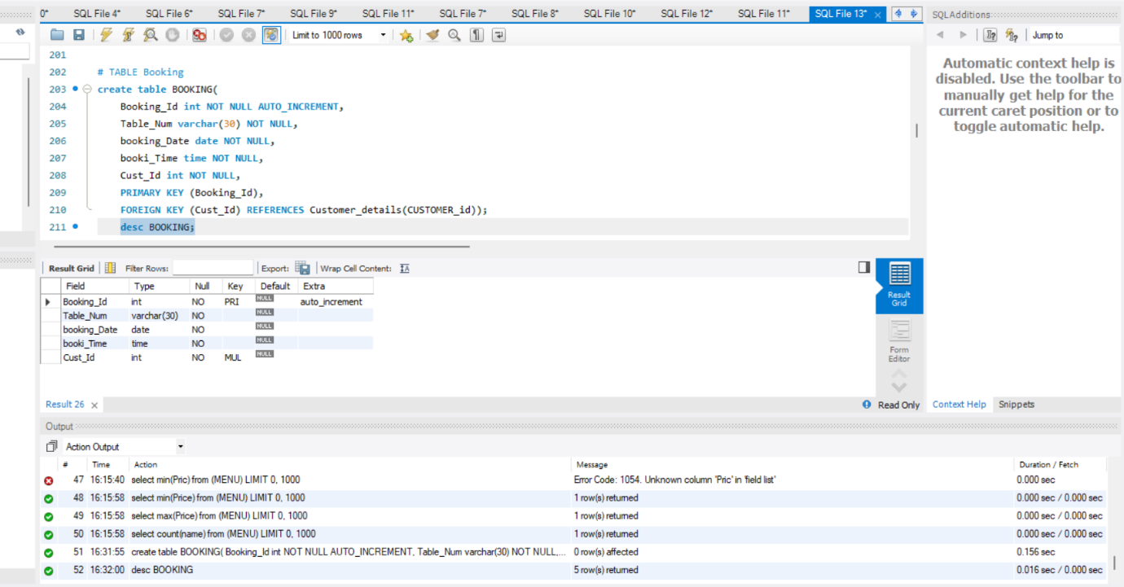

1. **Insert value Booking**

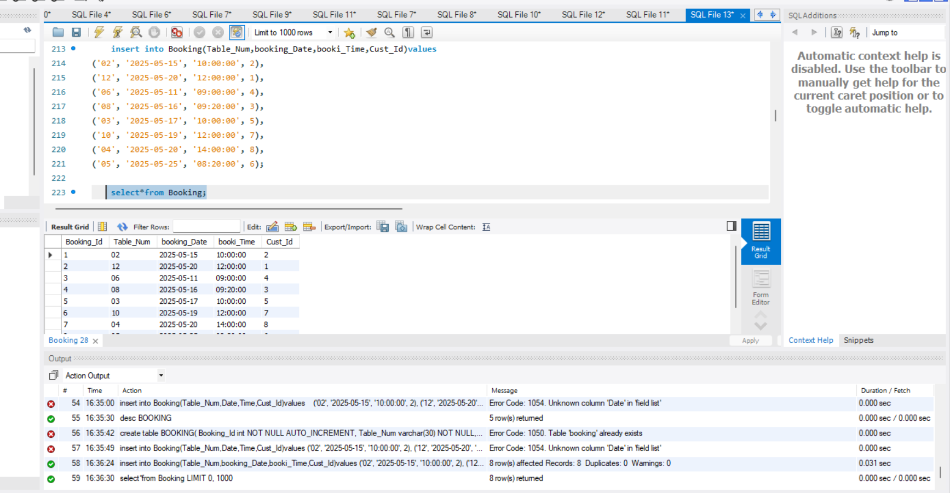

1. **BETWEEN Operator**

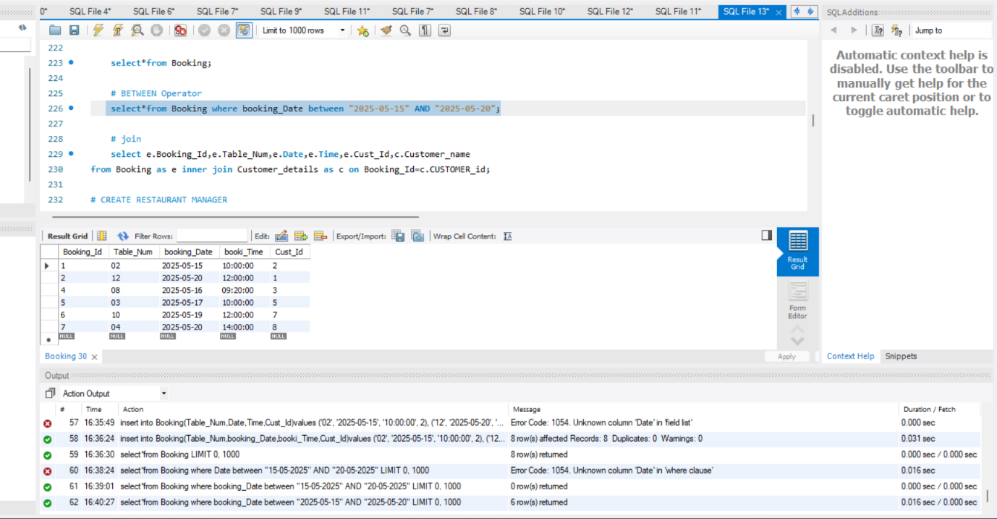

1. **Join**

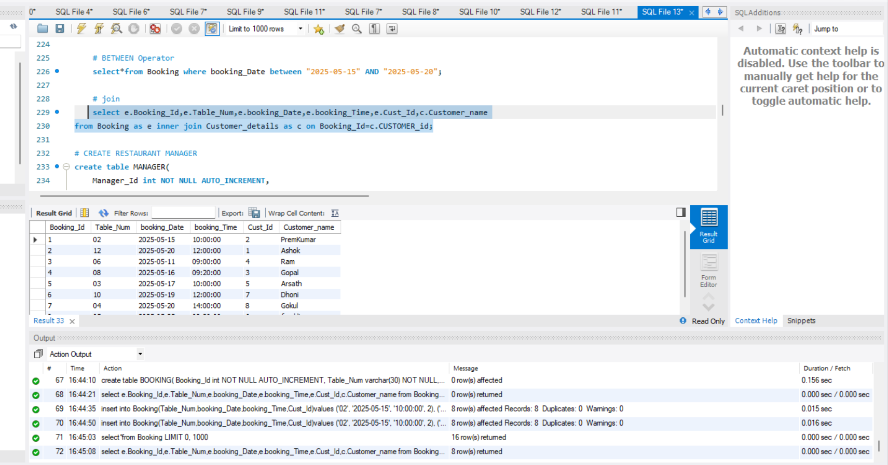

1. **CREATE RESTAURANT MANAGER**

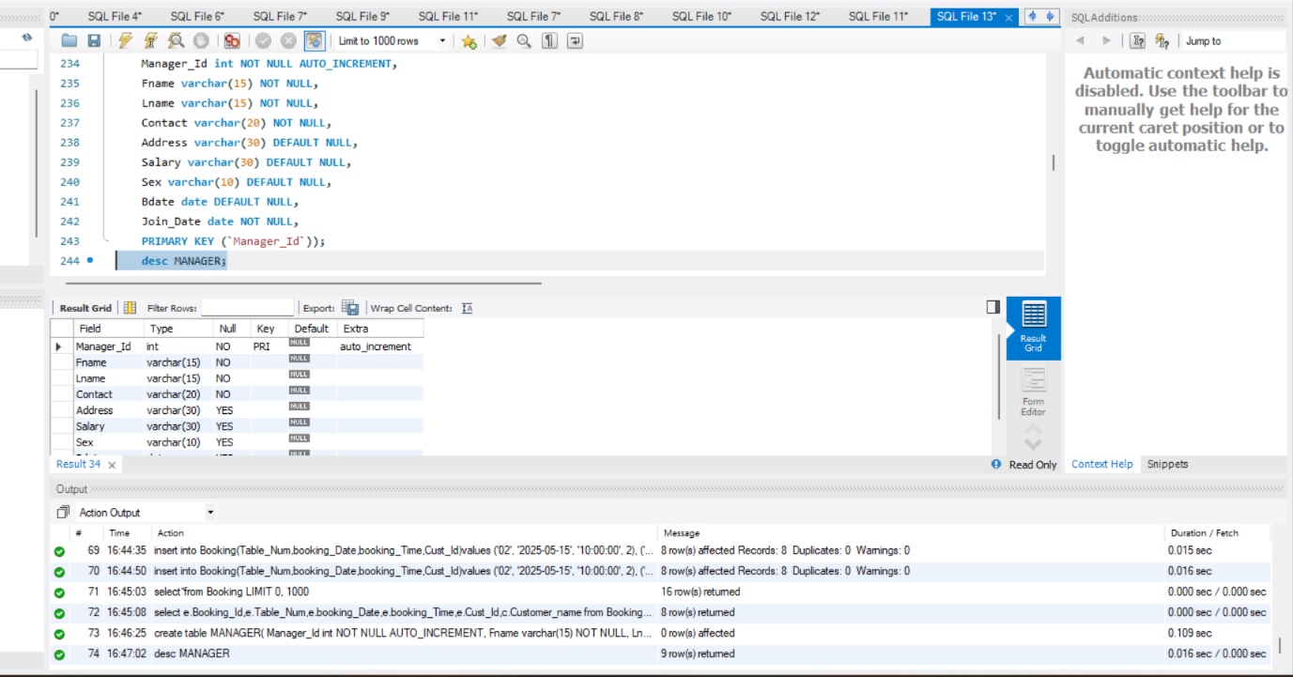

1. **Insert Value Manager Details**

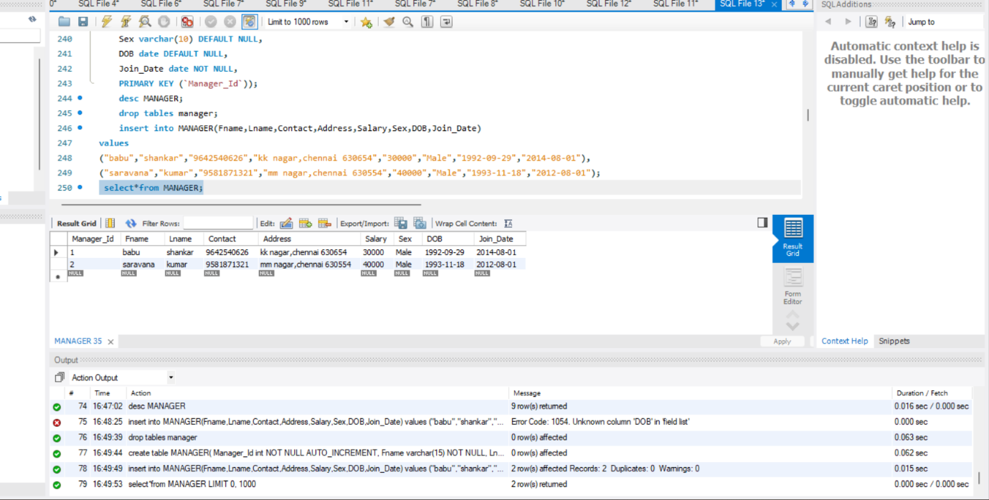

1. **CONCAT**

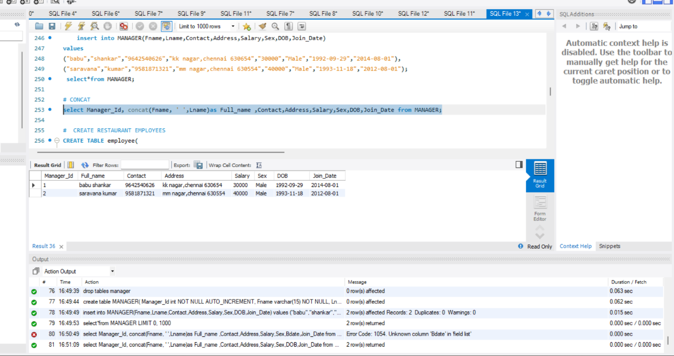

1. **CREATE RESTAURANT EMPLOYEES**

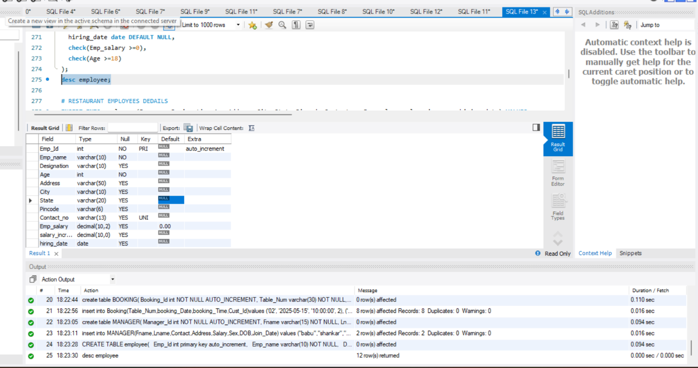

1. **RESTAURANT EMPLOYEES DEDAILS**

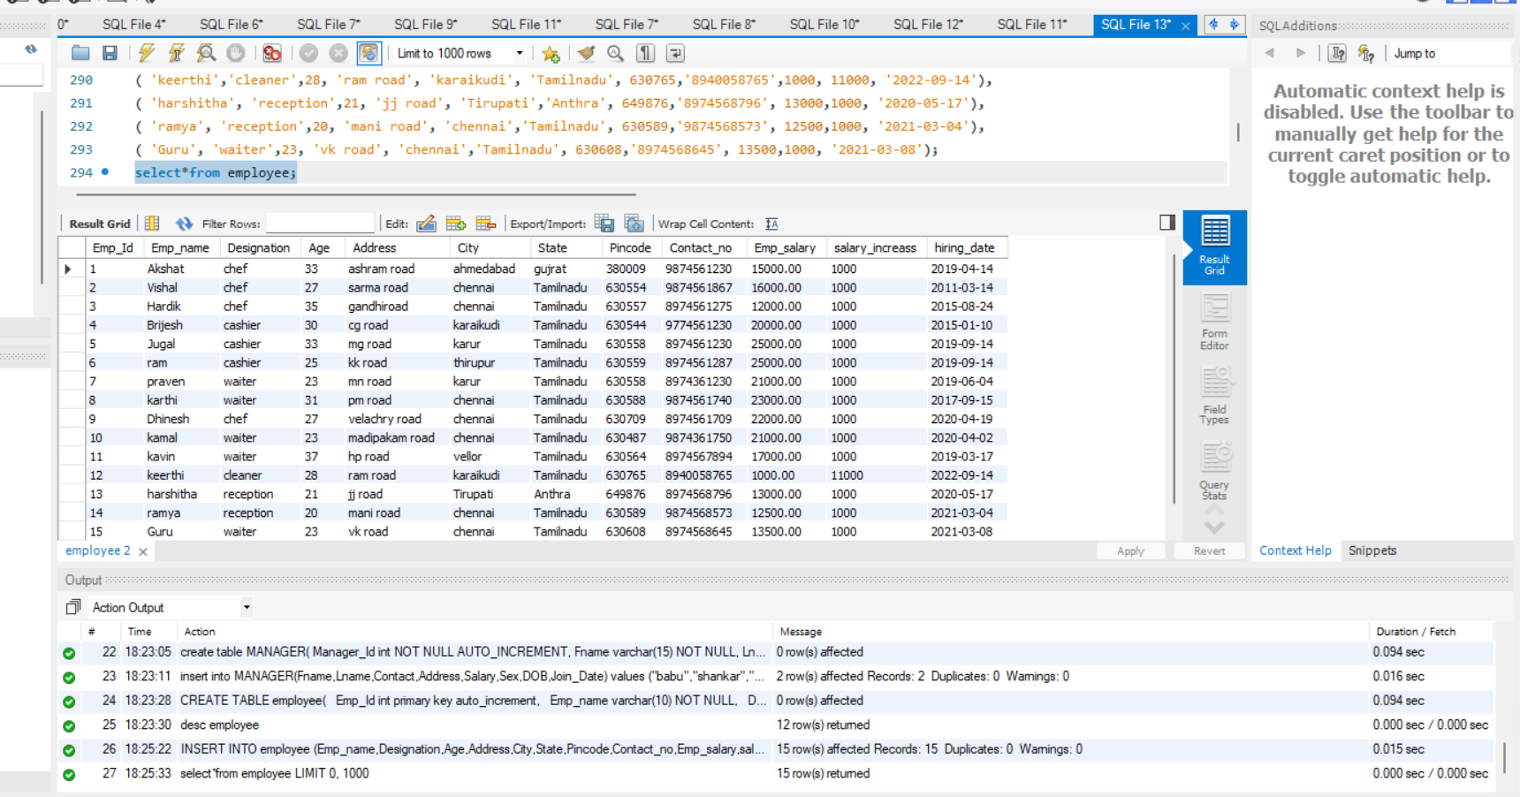

1. **String Function**

* **Upper case**

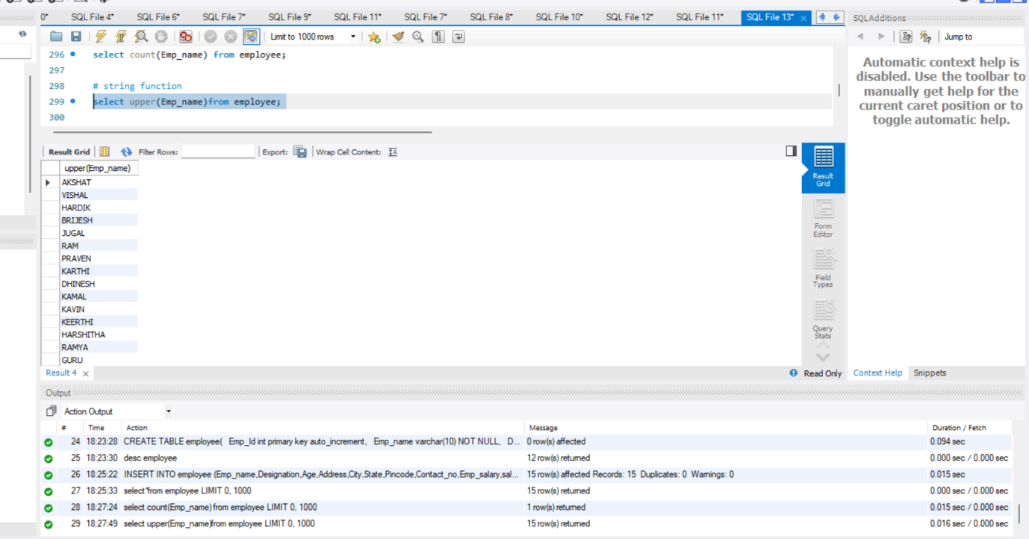

**Operators Based Retrieve Querys**

1. **Equality Operator (=)**

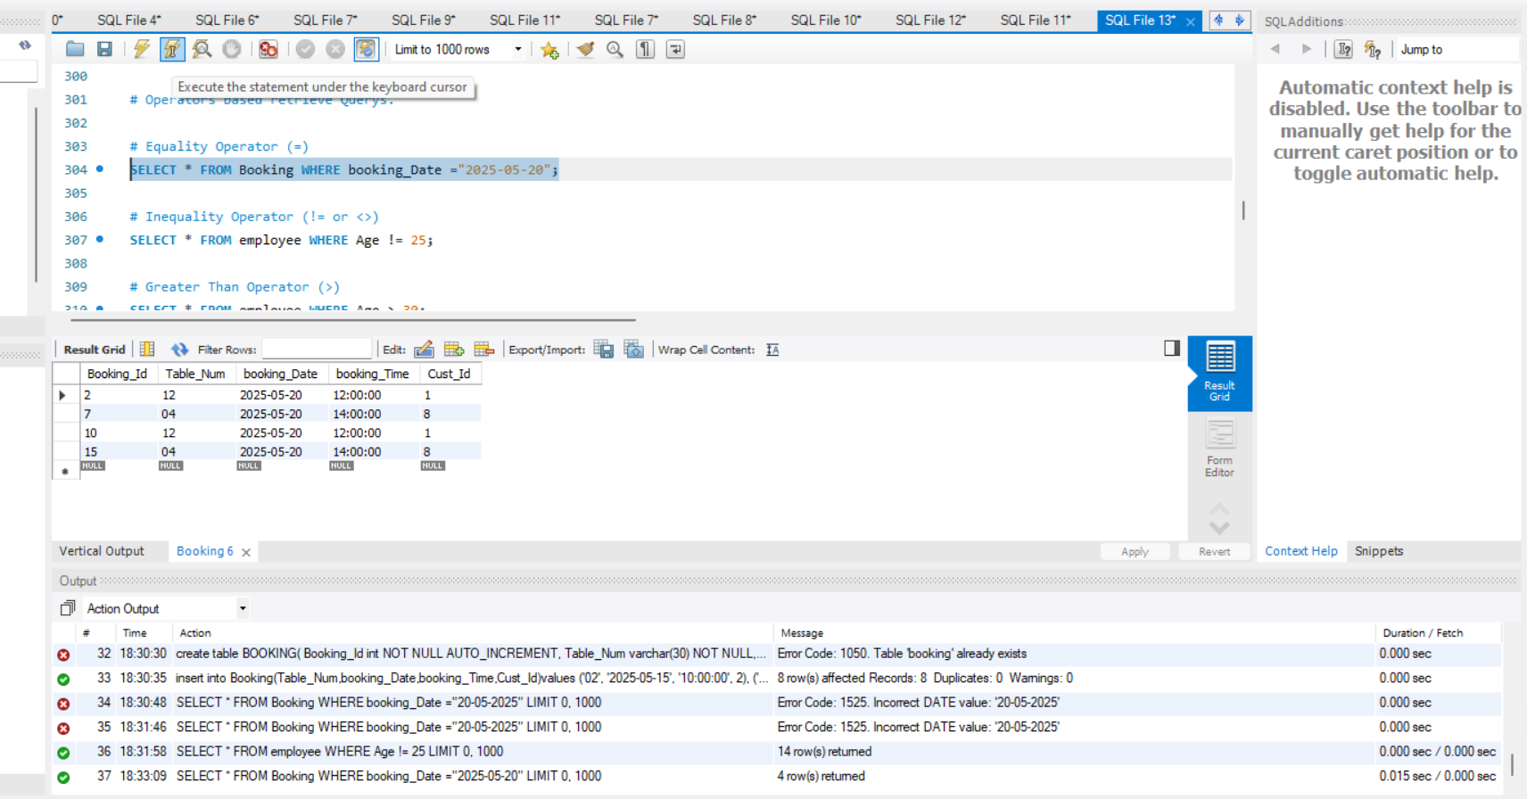

1. **Inequality Operator (!= or <>)**

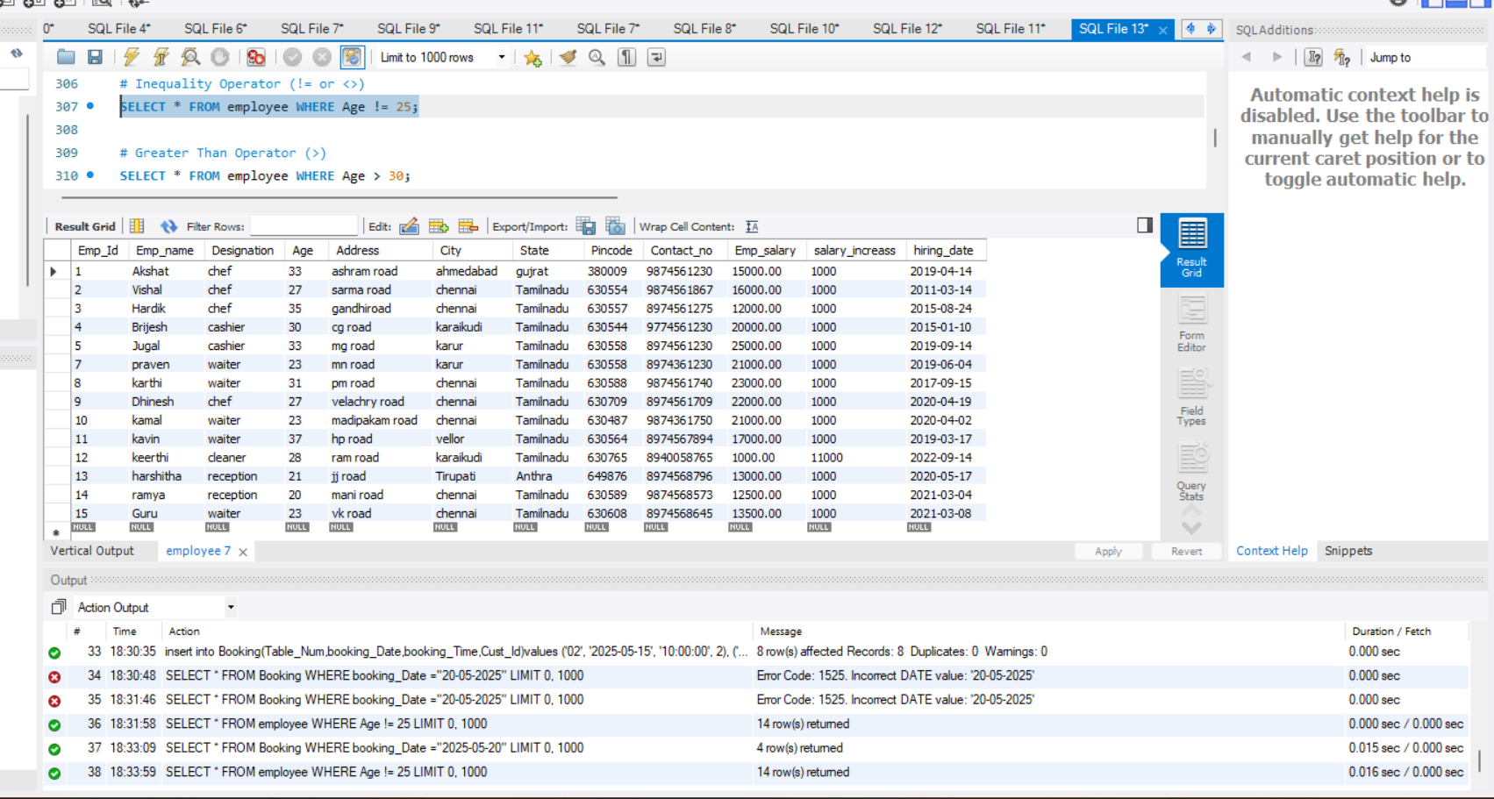

1. **Greater Than Operator (>)**

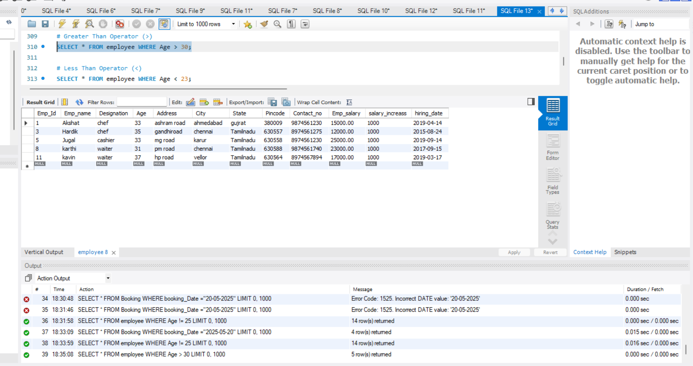

1. **Less Than Operator (<)**

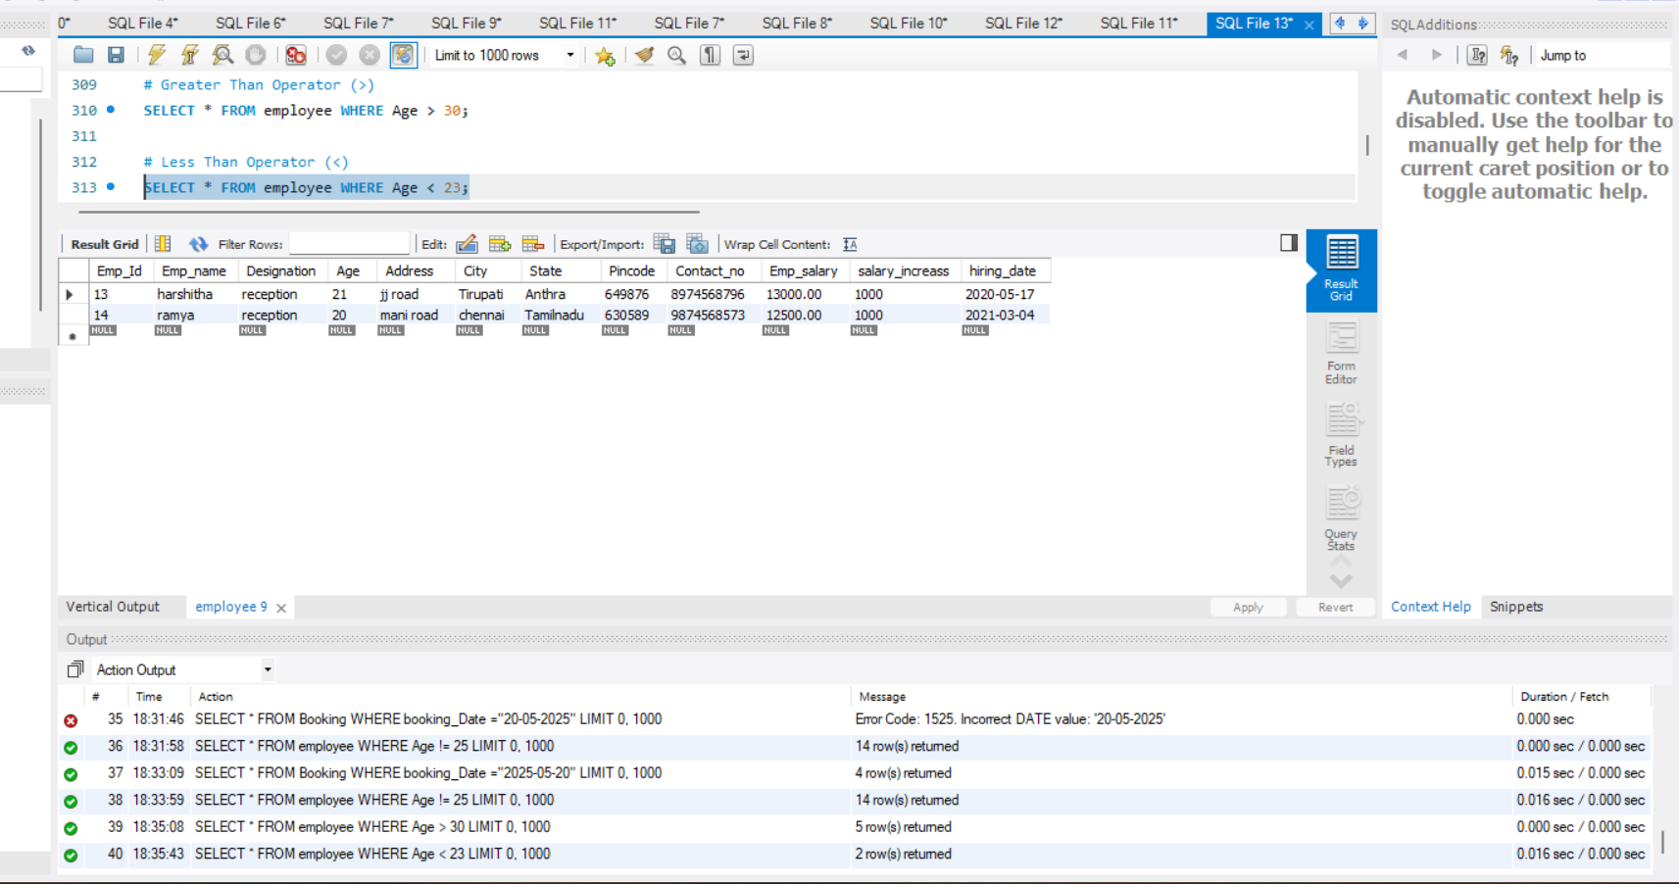

1. **Greater Than or Equal To Operator (>=)**

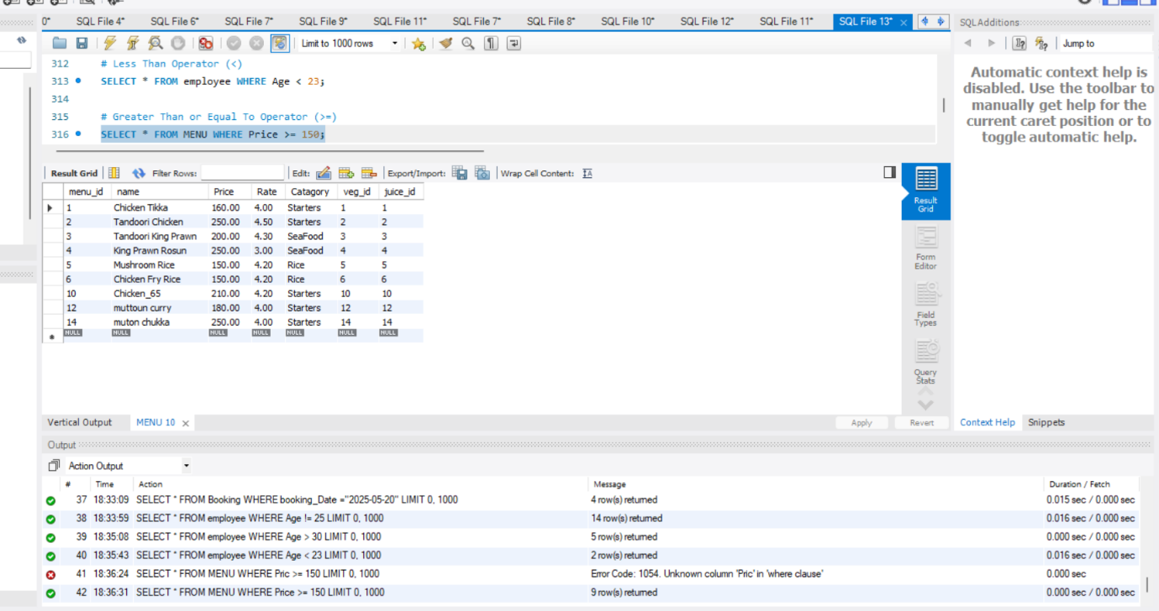

1. **Less Than or Equal To Operator (<=)**

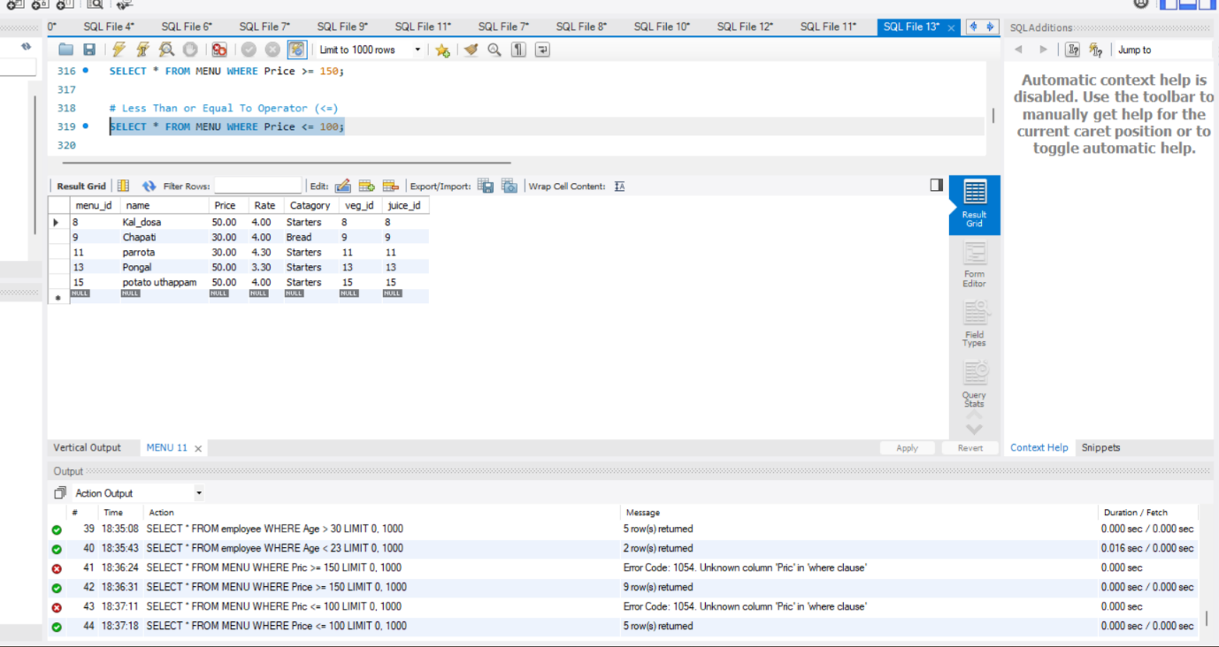

1. **BETWEEN Operator**

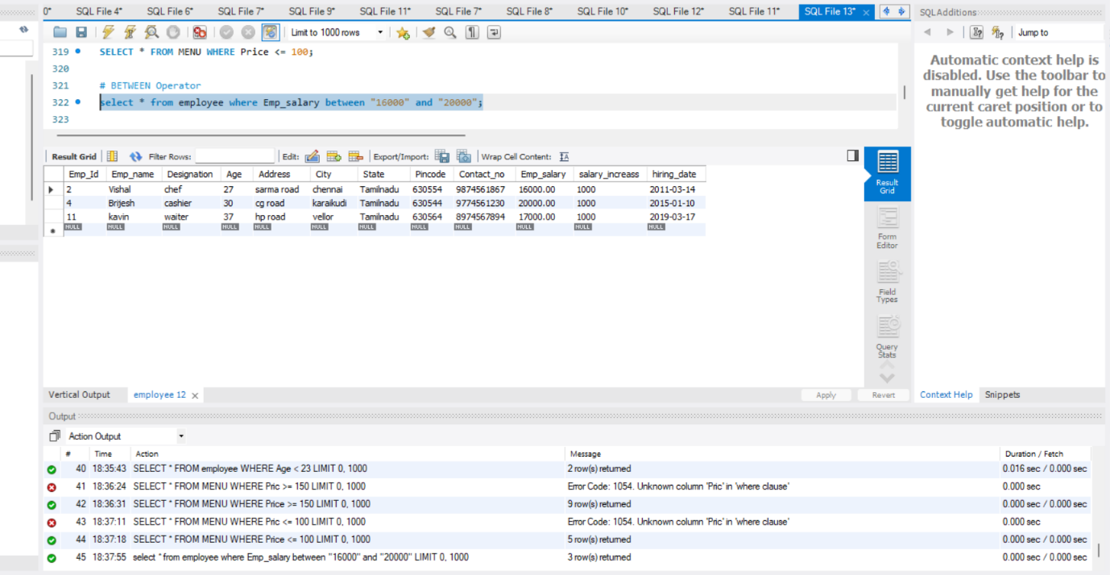

1. **IN Operator**

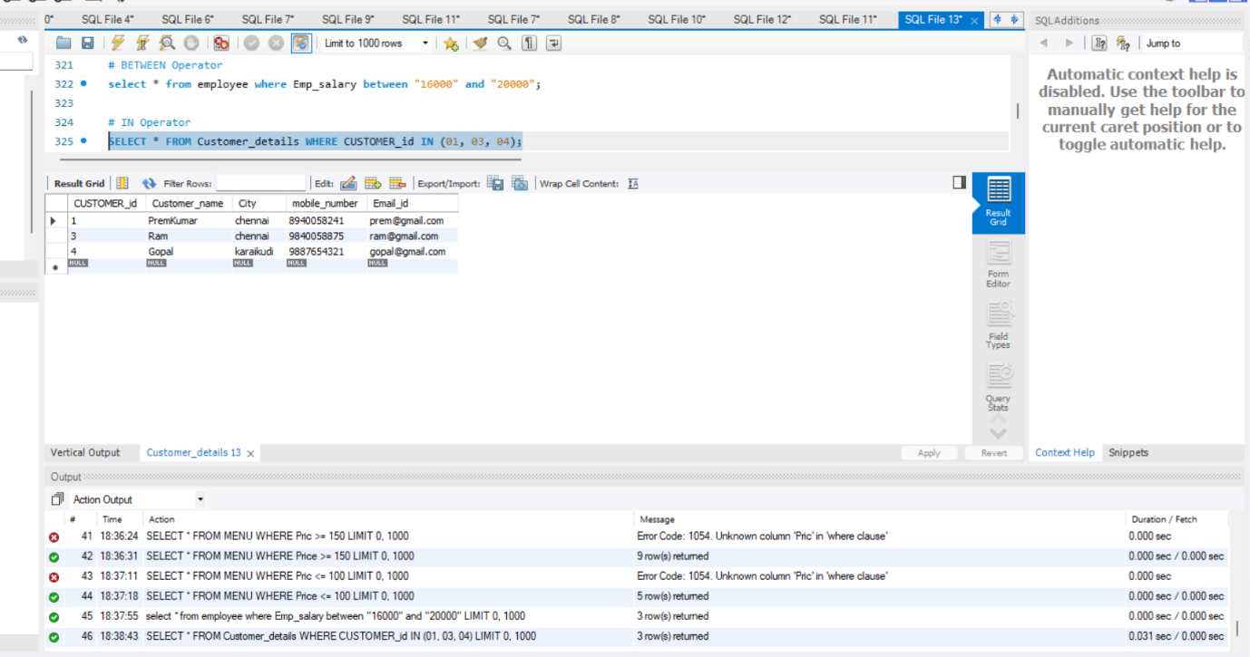

1. **LIKE Operator**

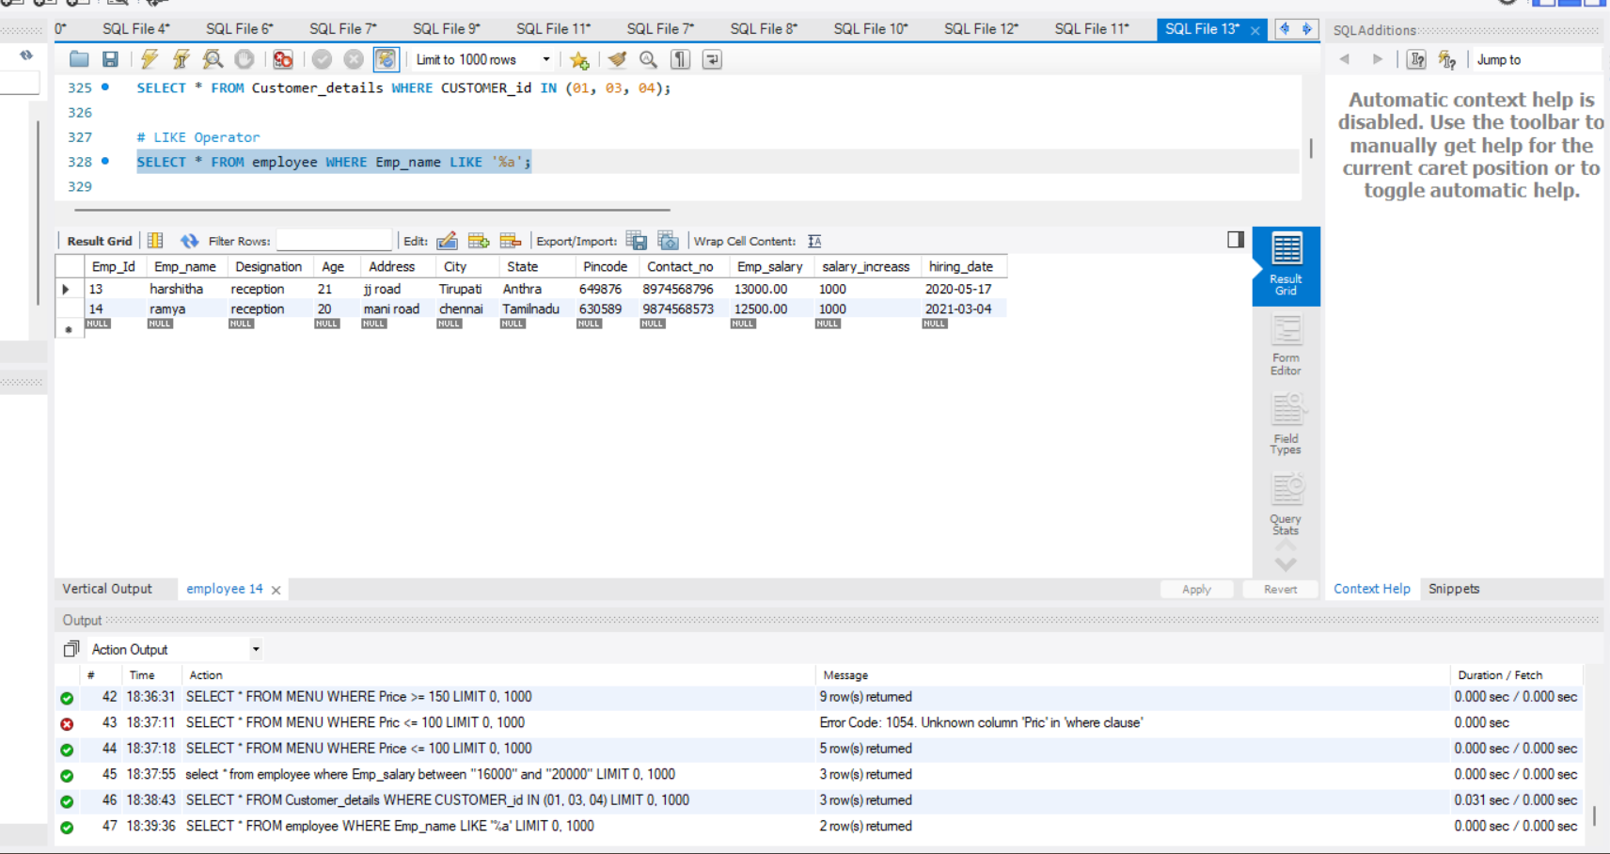

1. **AND Operator**

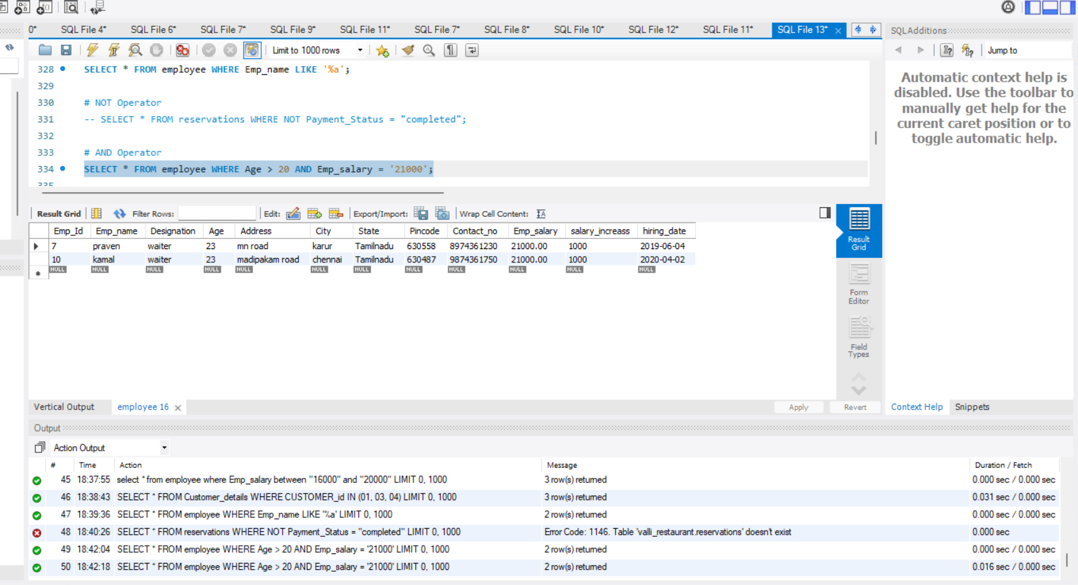

1. **OR Operator**

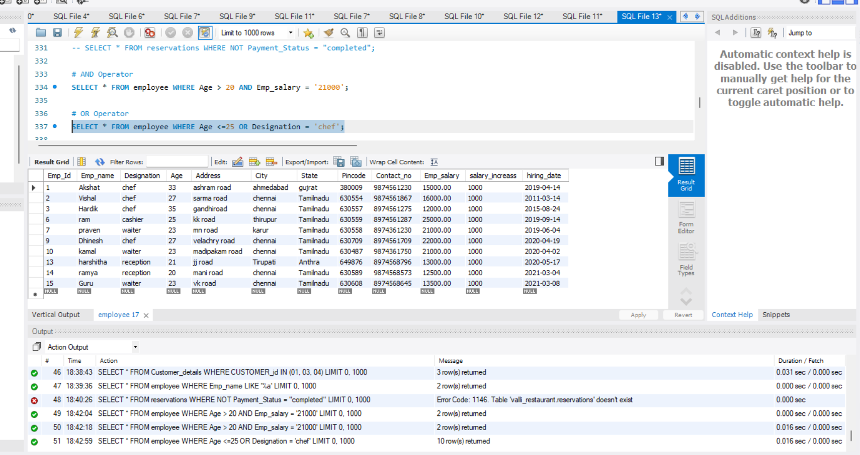

1. **Oreder by**

* **Ascending order**

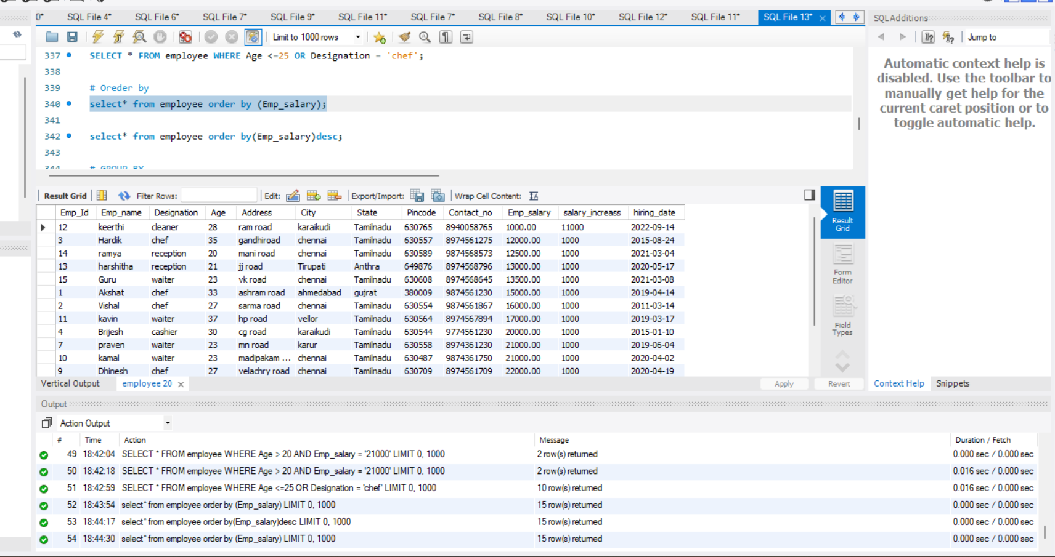

1. **Oreder by**

* **Descending order**

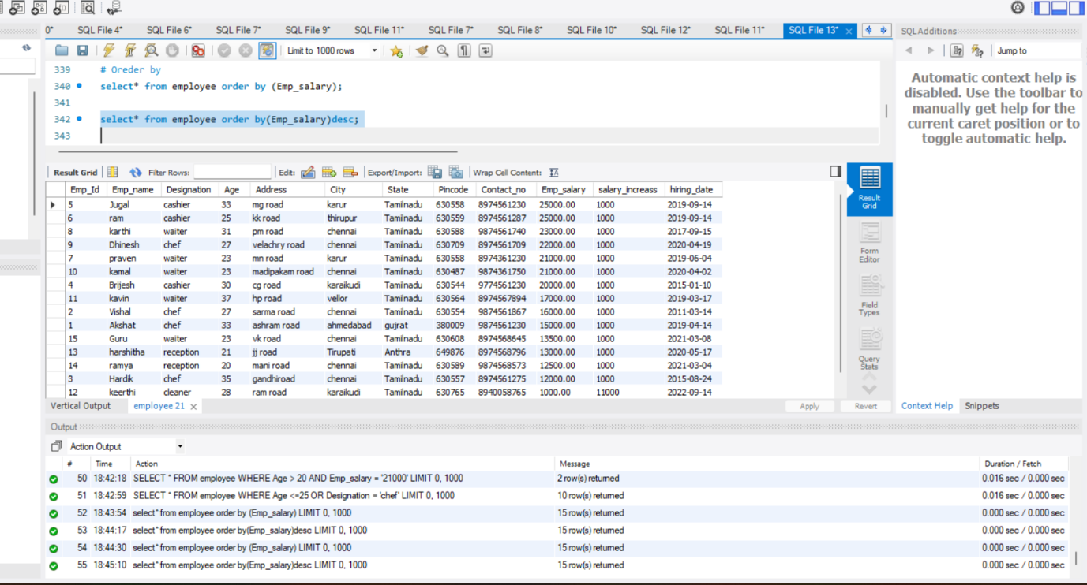

1. **GROUP BY**

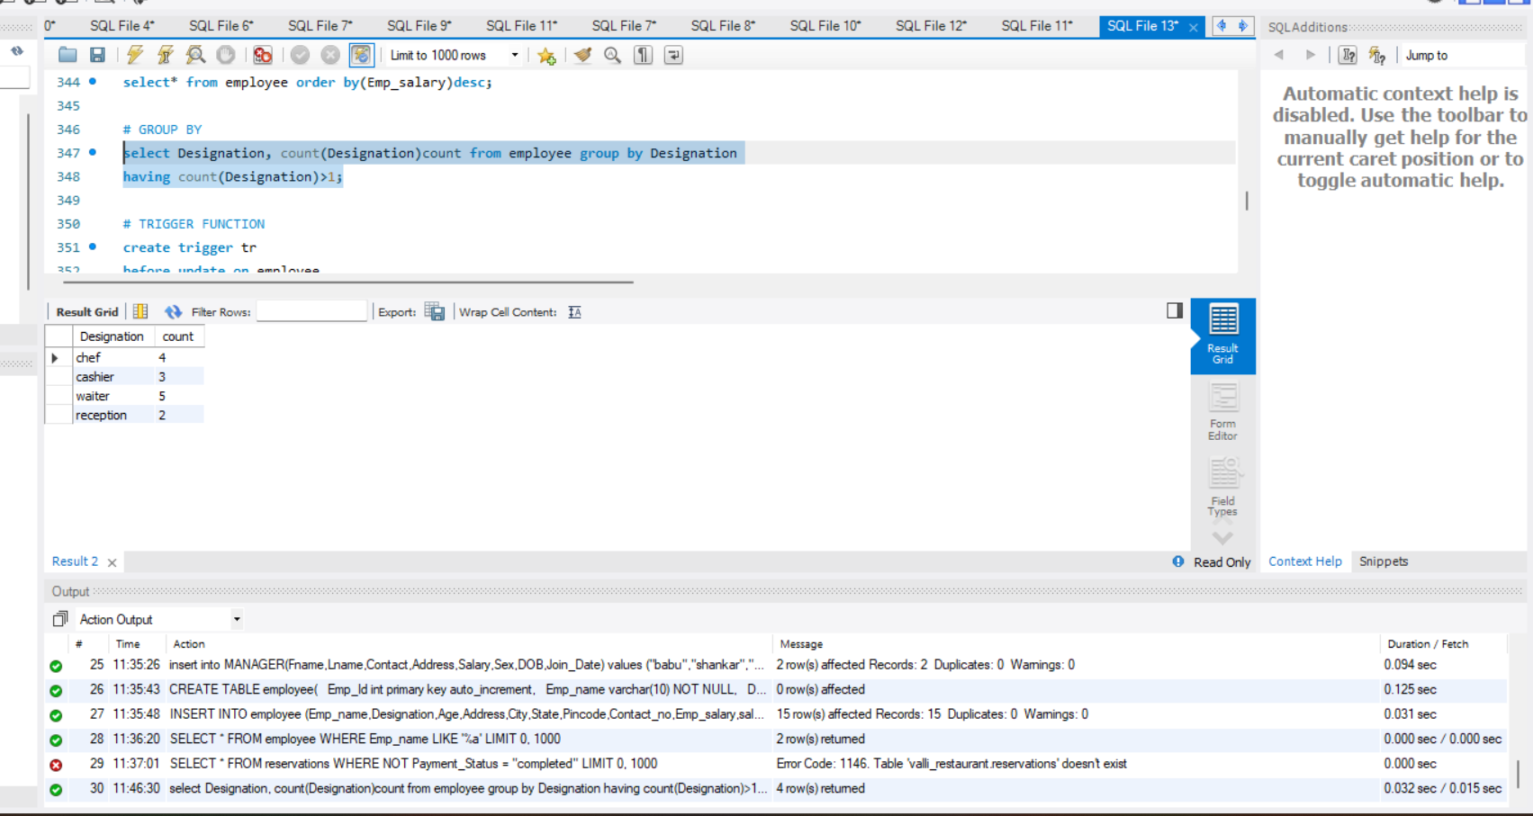

1. **TRIGGER FUNCTION**

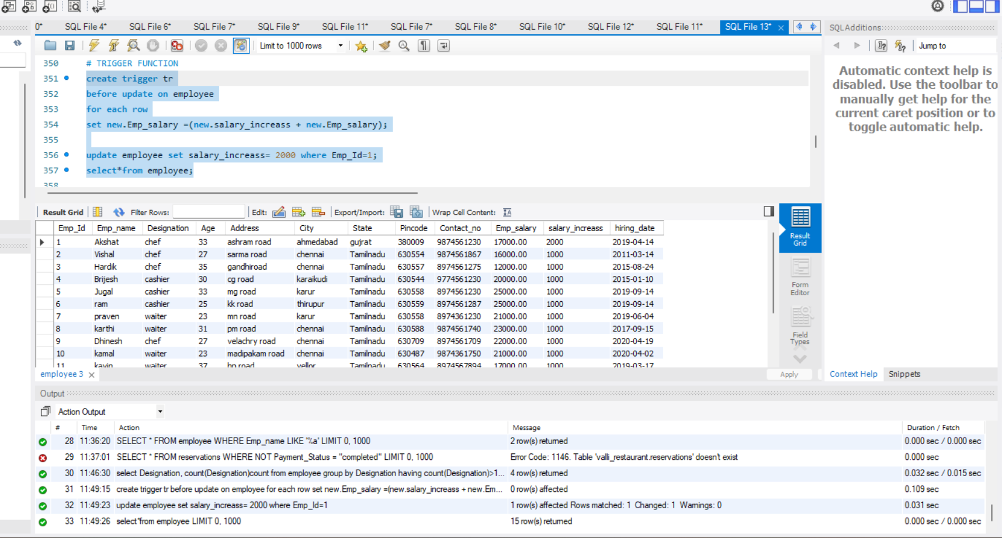

1. **SUB QUERY**

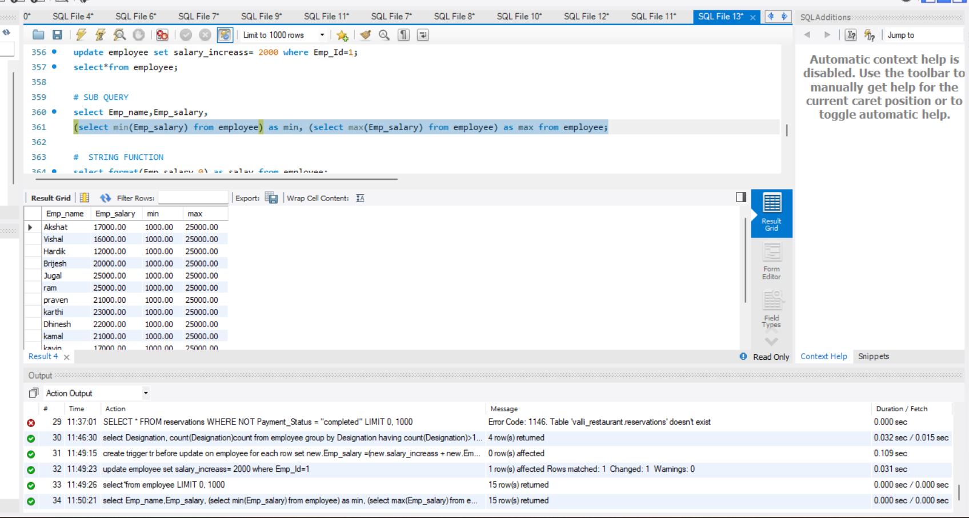

1. **STRING FUNCTION**

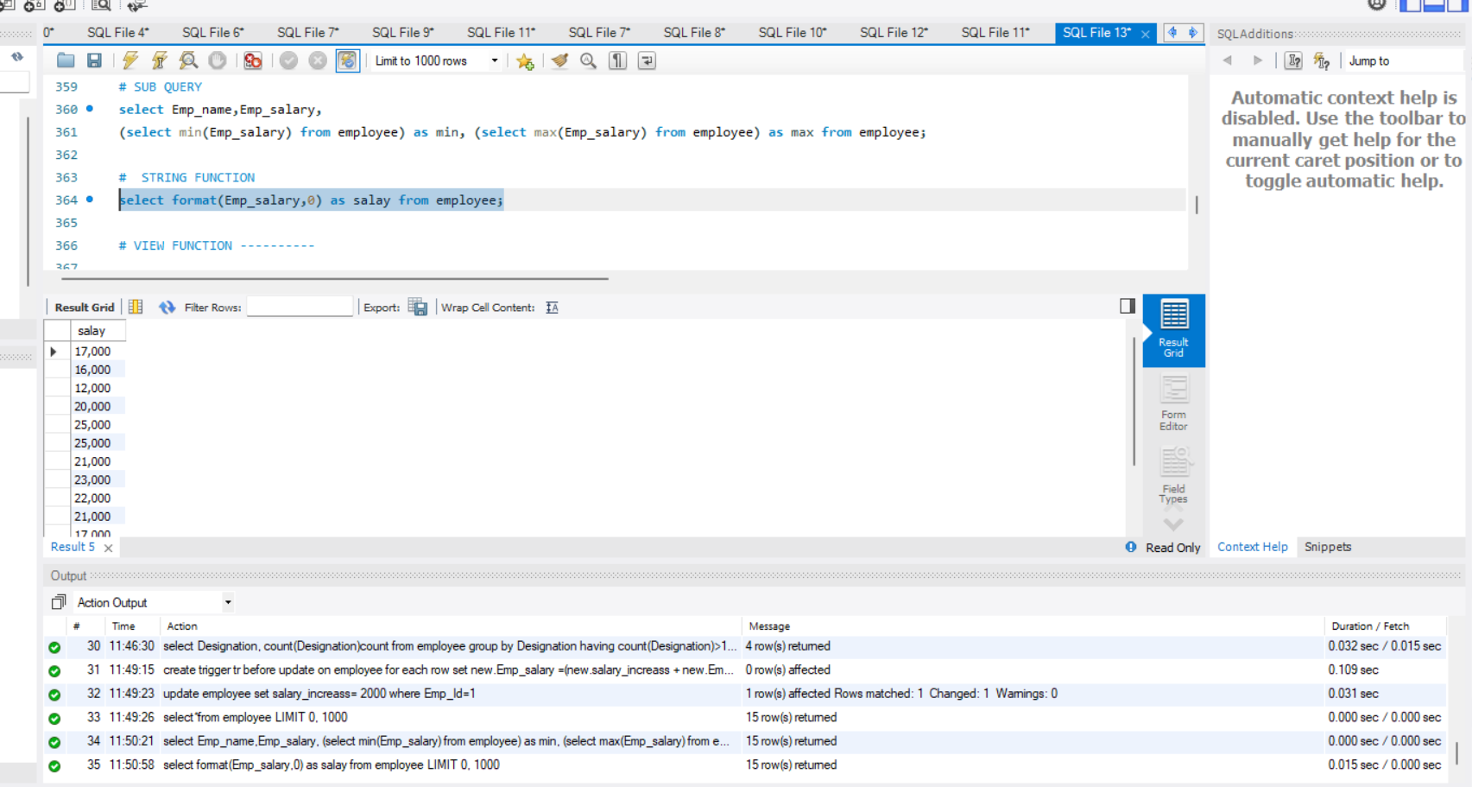

1. **VIEW FUNCTION (HOW MANY CHEF EMPLOYEE IN RESTAURANT)**

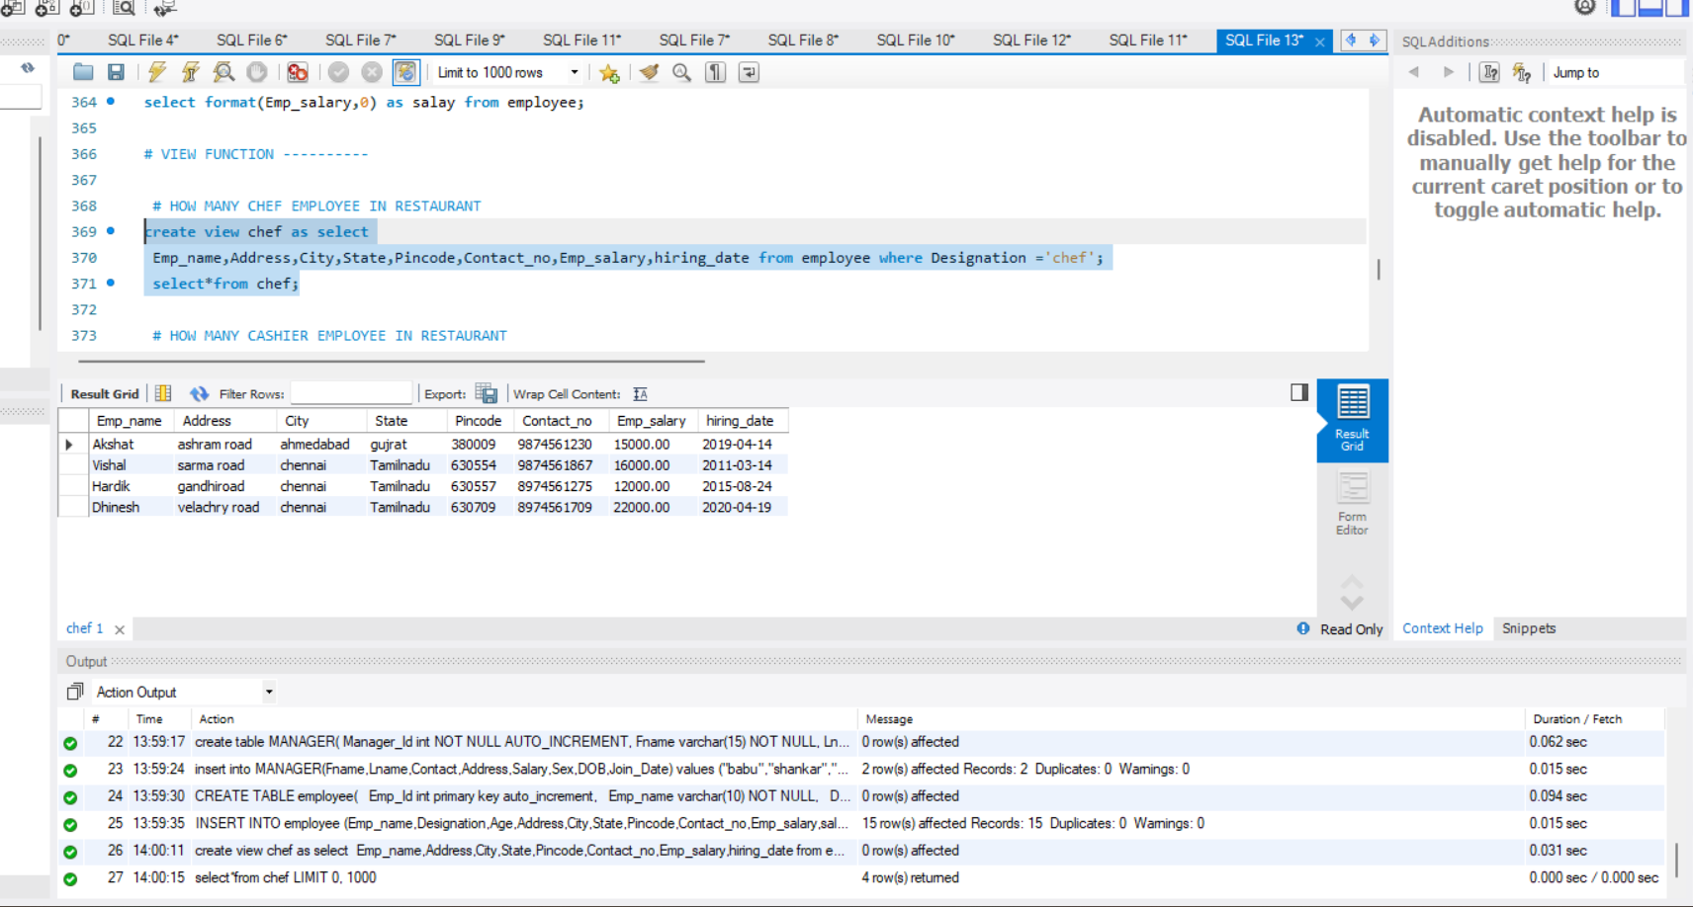

1. **VIEW FUNCTION (HOW MANY CASHIER EMPLOYEE IN RESTAURANT)**

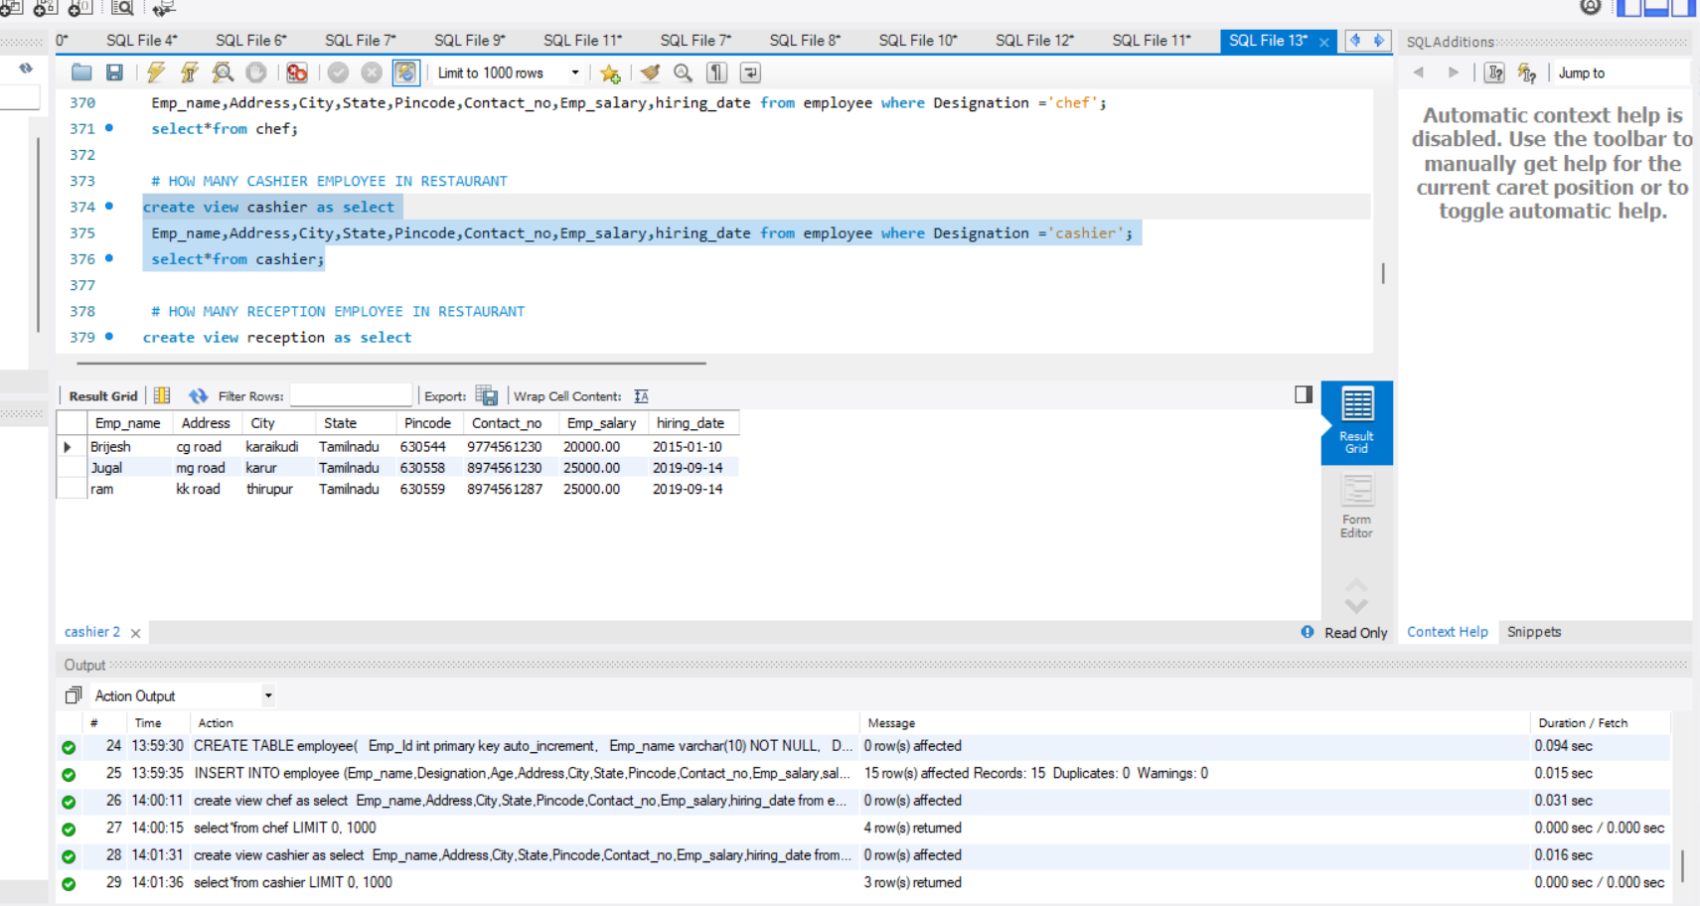

1. **VIEW FUNCTION (HOW MANY RECEPTION EMPLOYEE IN RESTAURANT)**

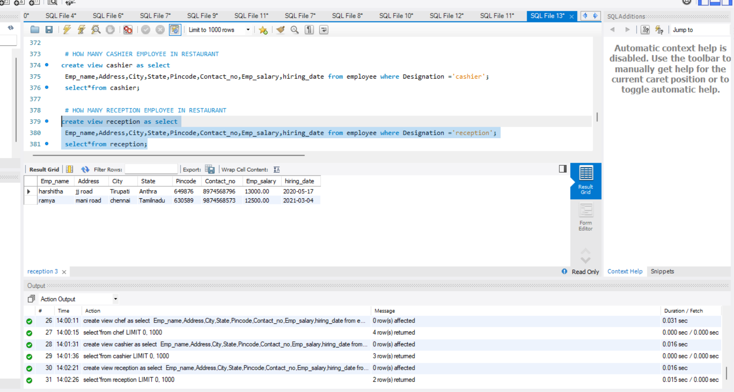

1. **VIEW FUNCTION (HOW MANY WAITER EMPLOYEE IN RESTAURANT)**

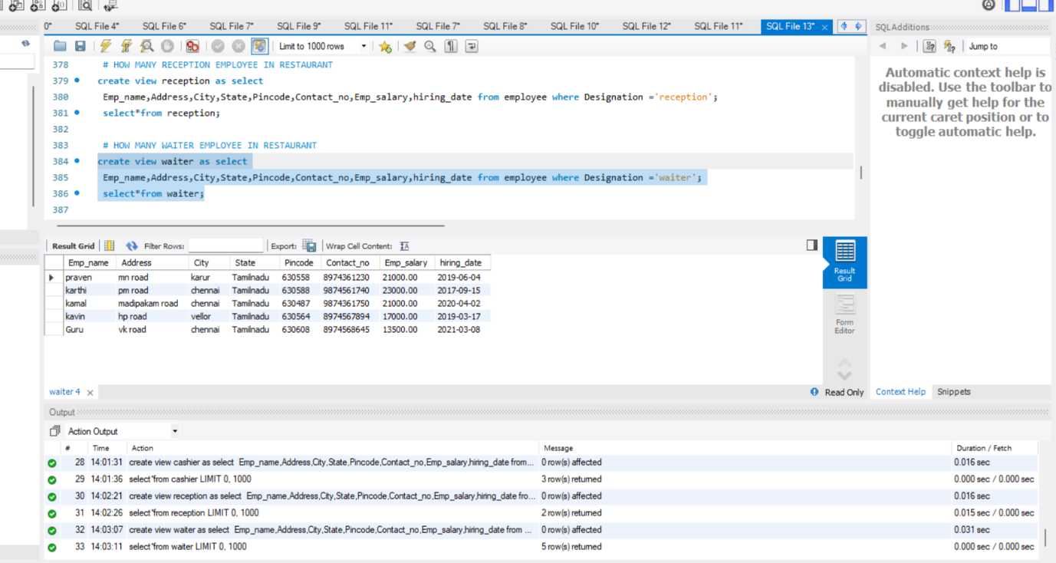

1. **CUSTOMER ORDER ITEMS**

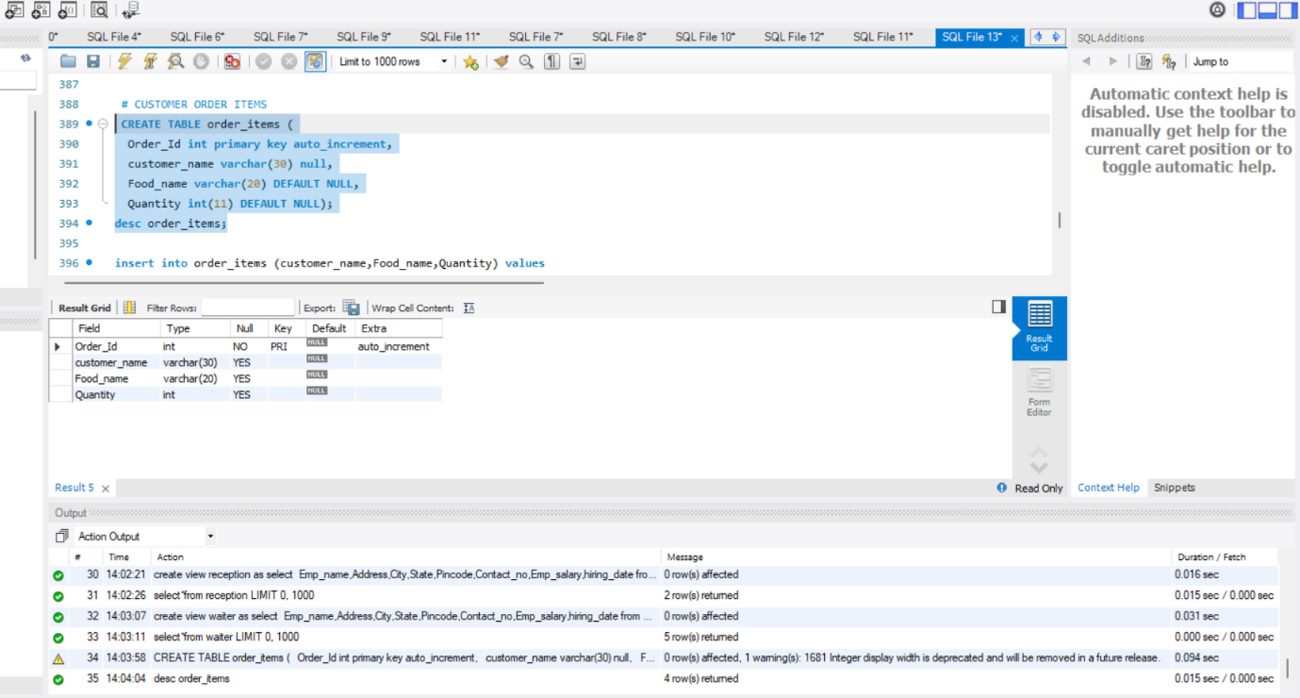

1. **INSERT VALUES CUSTOMER ORDER ITEMS**

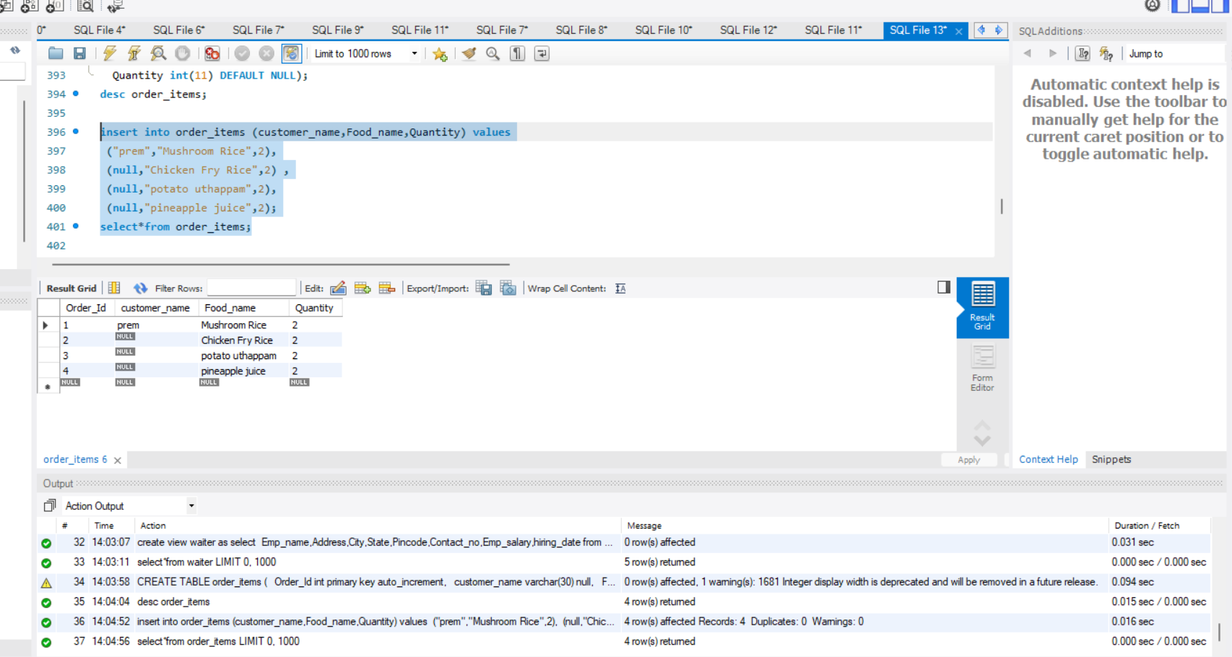

1. **FIRST CUSTOMER BILL**

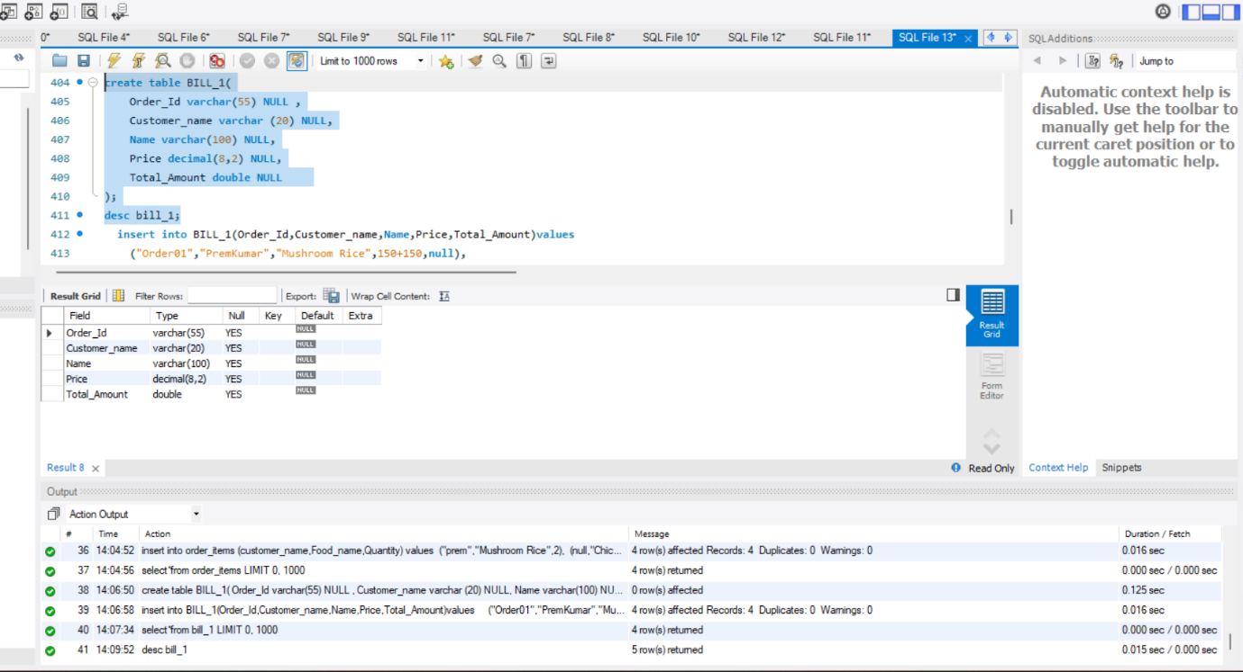

1. **INSERT VALUE BILL**

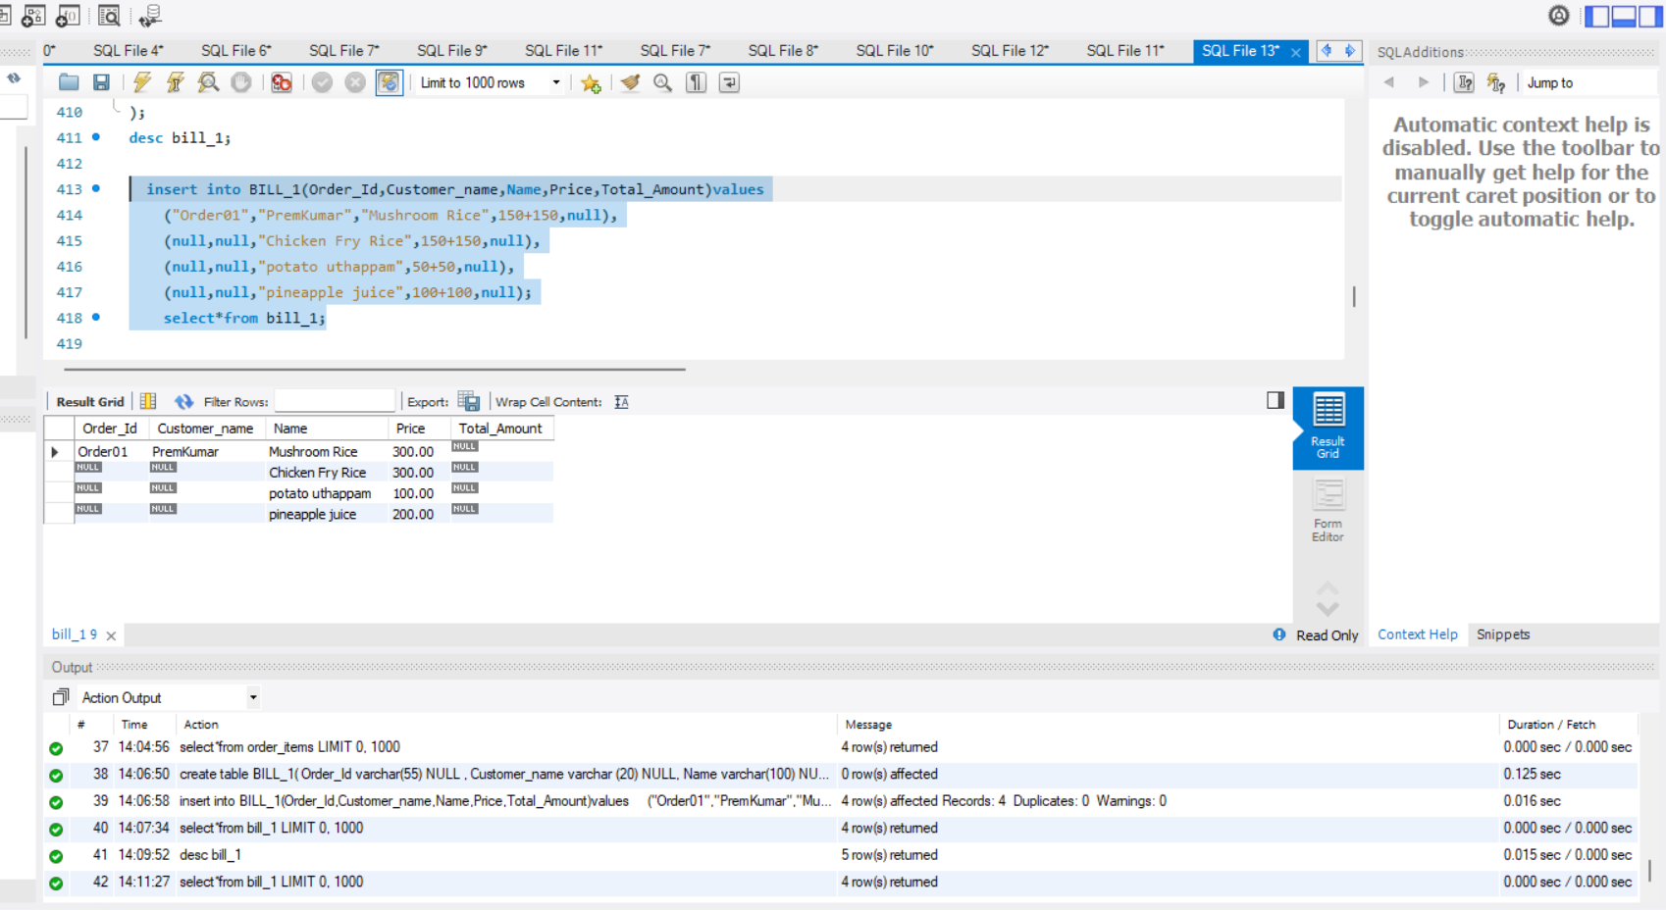

1. **SUM USED**

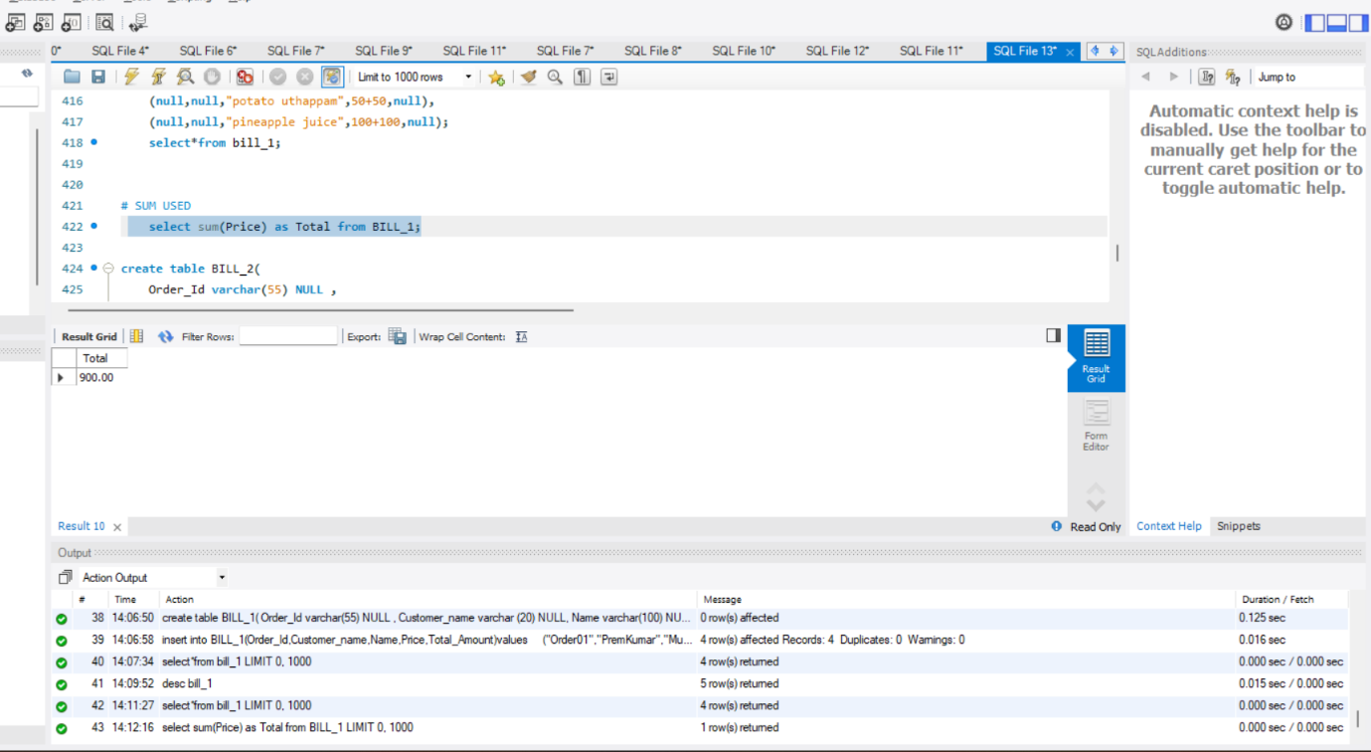

1. **SECOND CUSTOMER BILL**

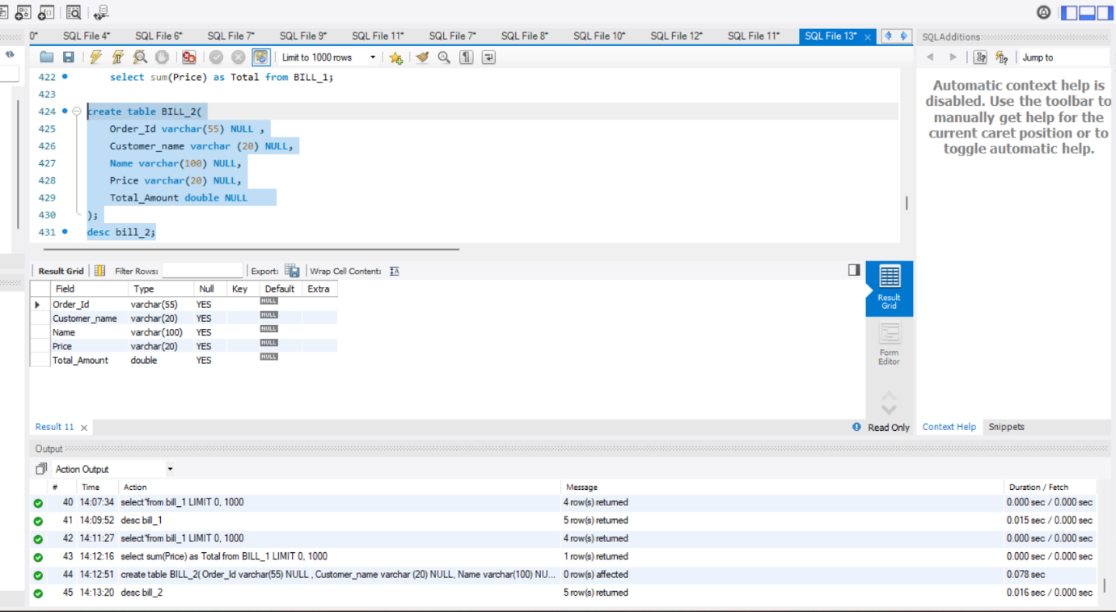

1. **INSERT VALUE BILL 2**

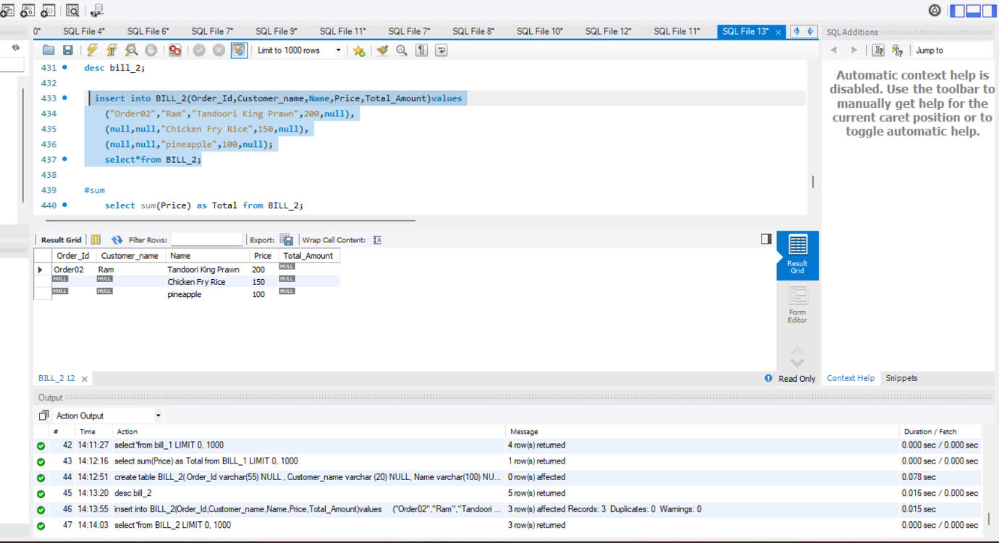

1. **Sum**

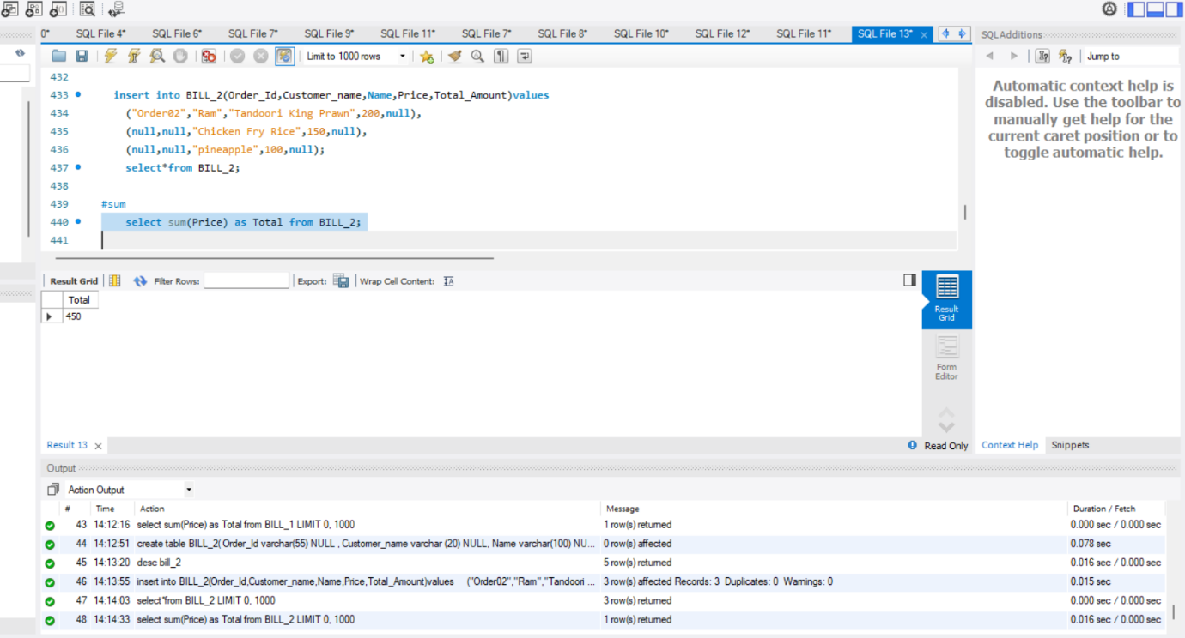

1. **FOOD HOME_DELIVERY**

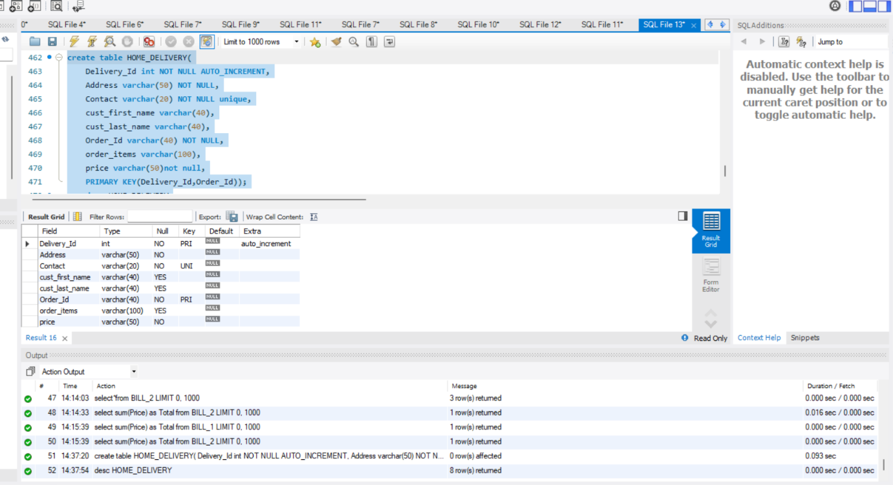

1. **INSERT VALUE FOOD HOME_DELIVERY**

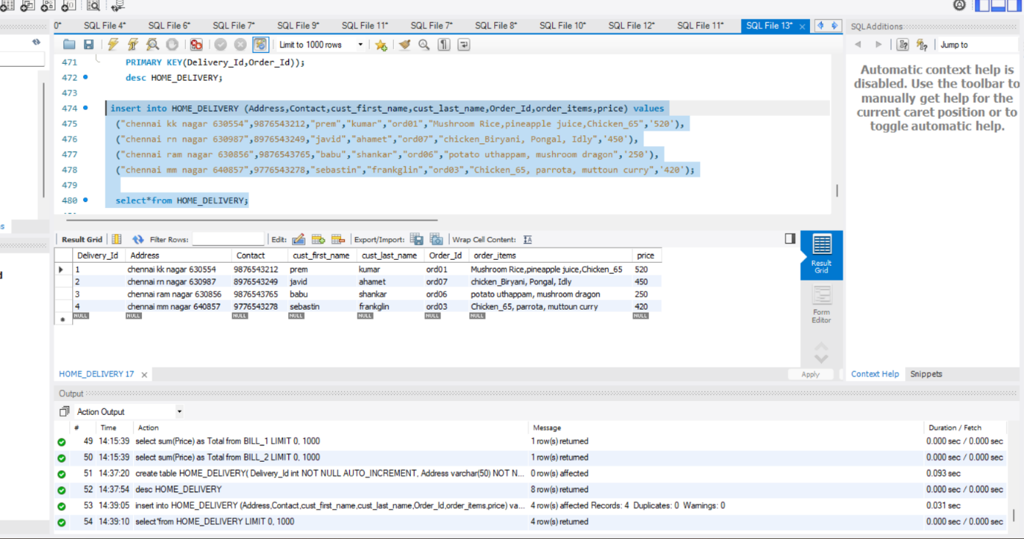

1. **STORED PROCEDURE (Insert value)**

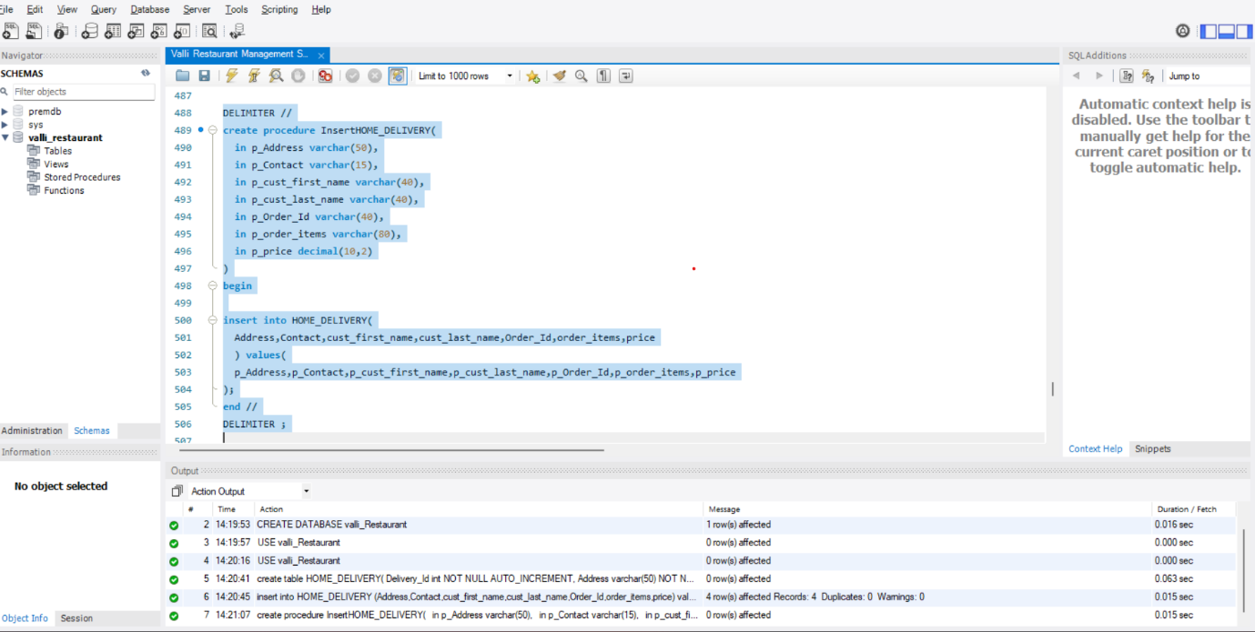

**65 .INSERT VALUE**

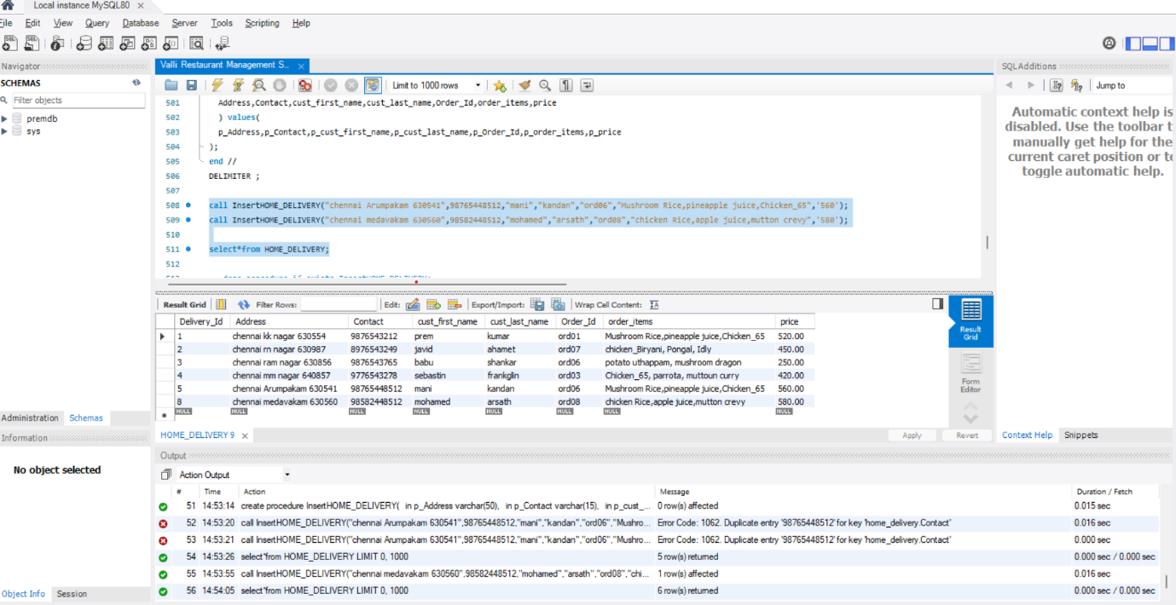

**66.UPDATE PROCEDURE**

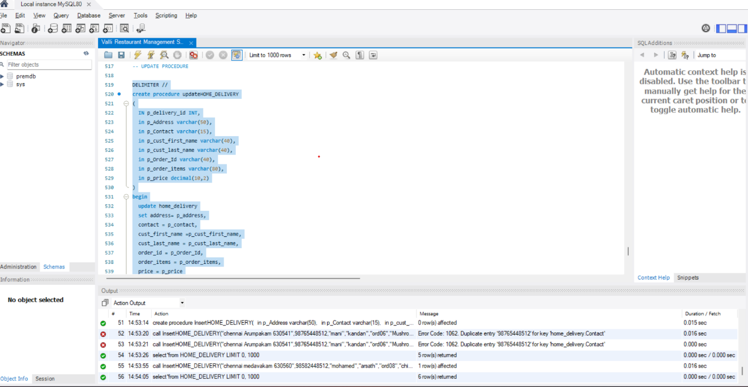

**67. UPDATE (ONE VALUE)**

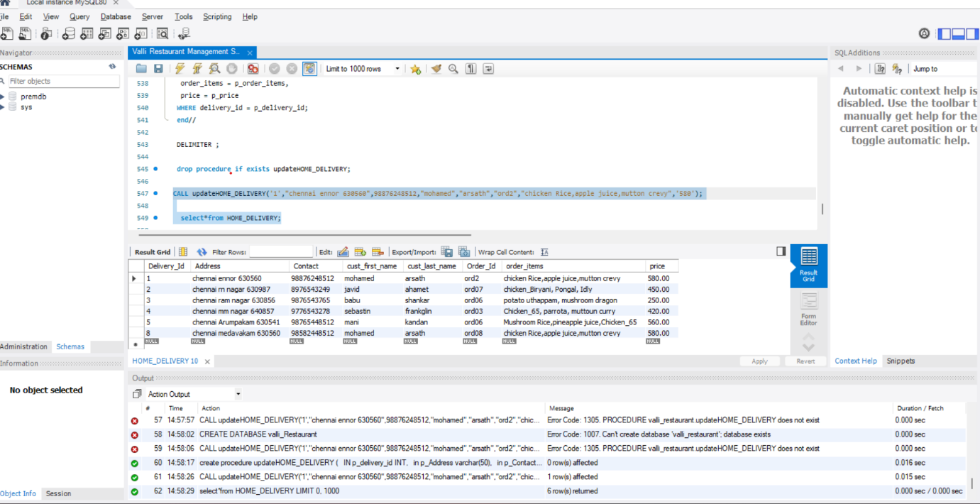

**68. DELETE PROCEDURE**

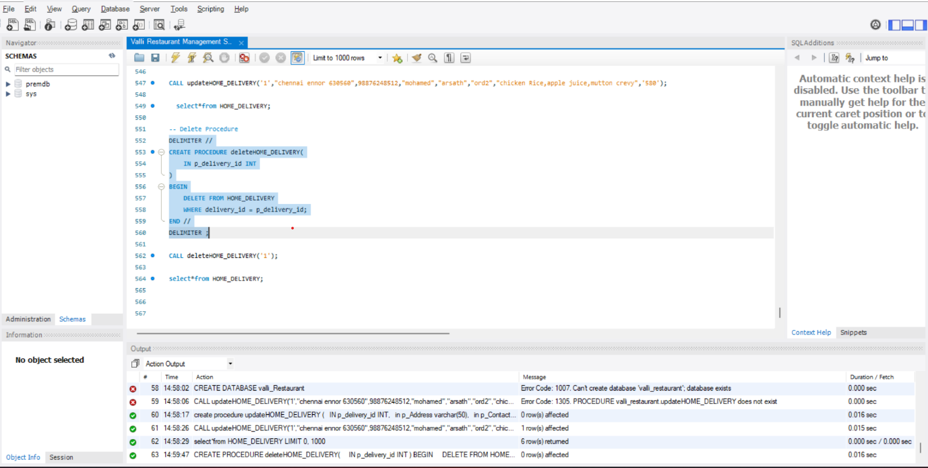

**69. DELETE (ONE VALUE)**

